1. Pwd

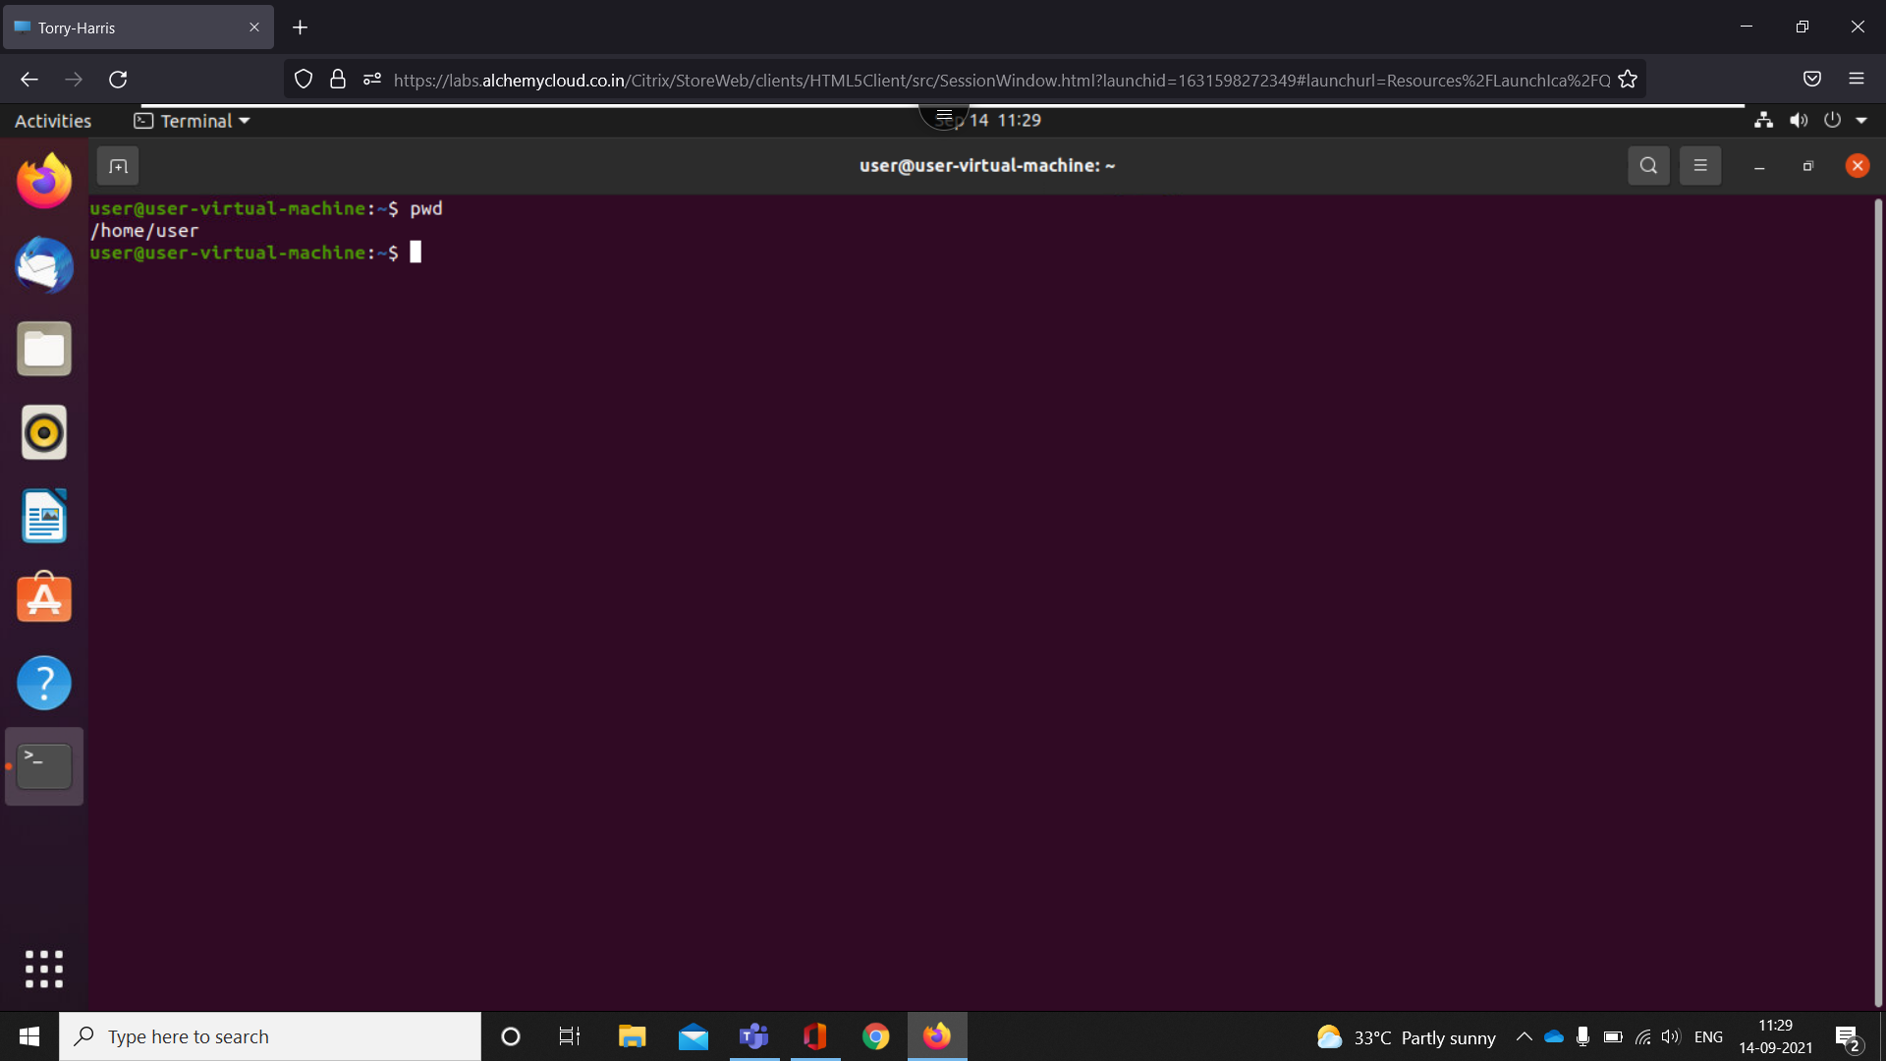

It prints the path of the working directory, starting from the root.

1. Clear

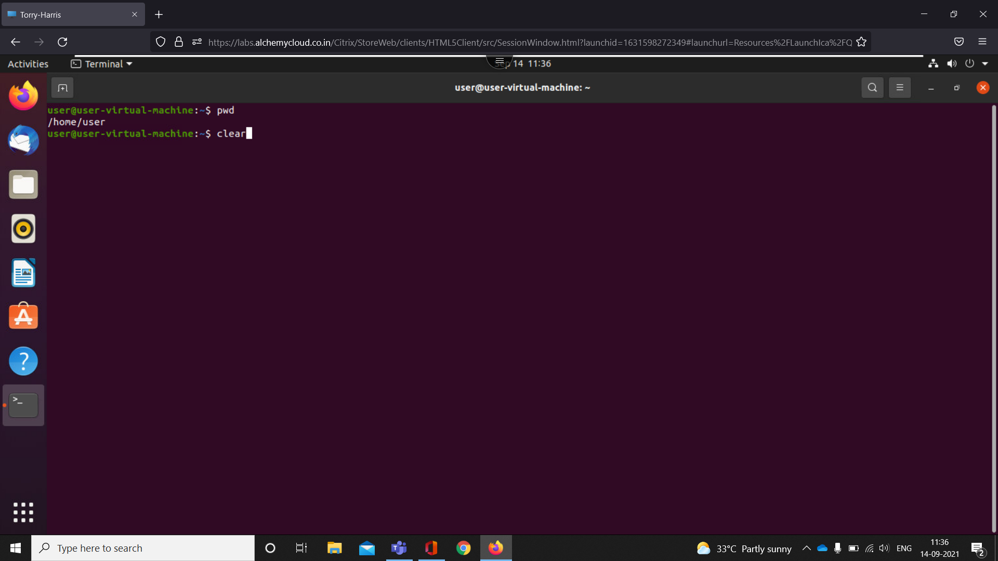

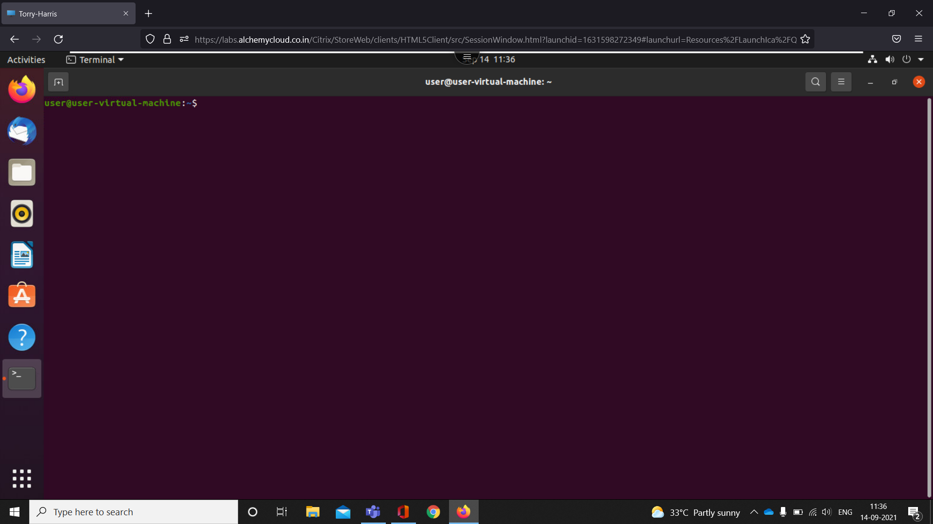

It is used to clear the terminal screen

1. Ls

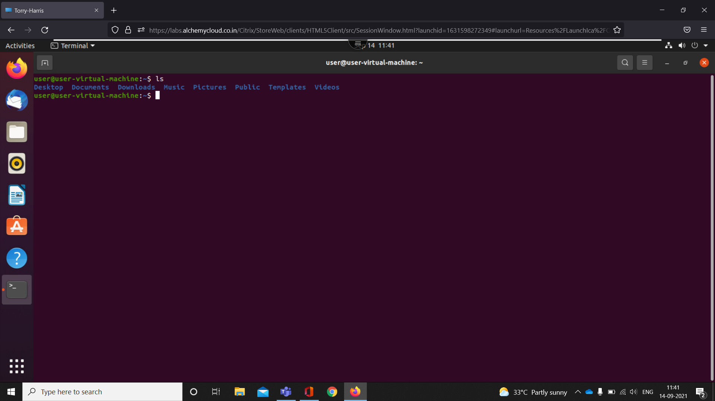

The Linux ls command allows you to view a list of the files and folders in a given directory

1. Ls – l

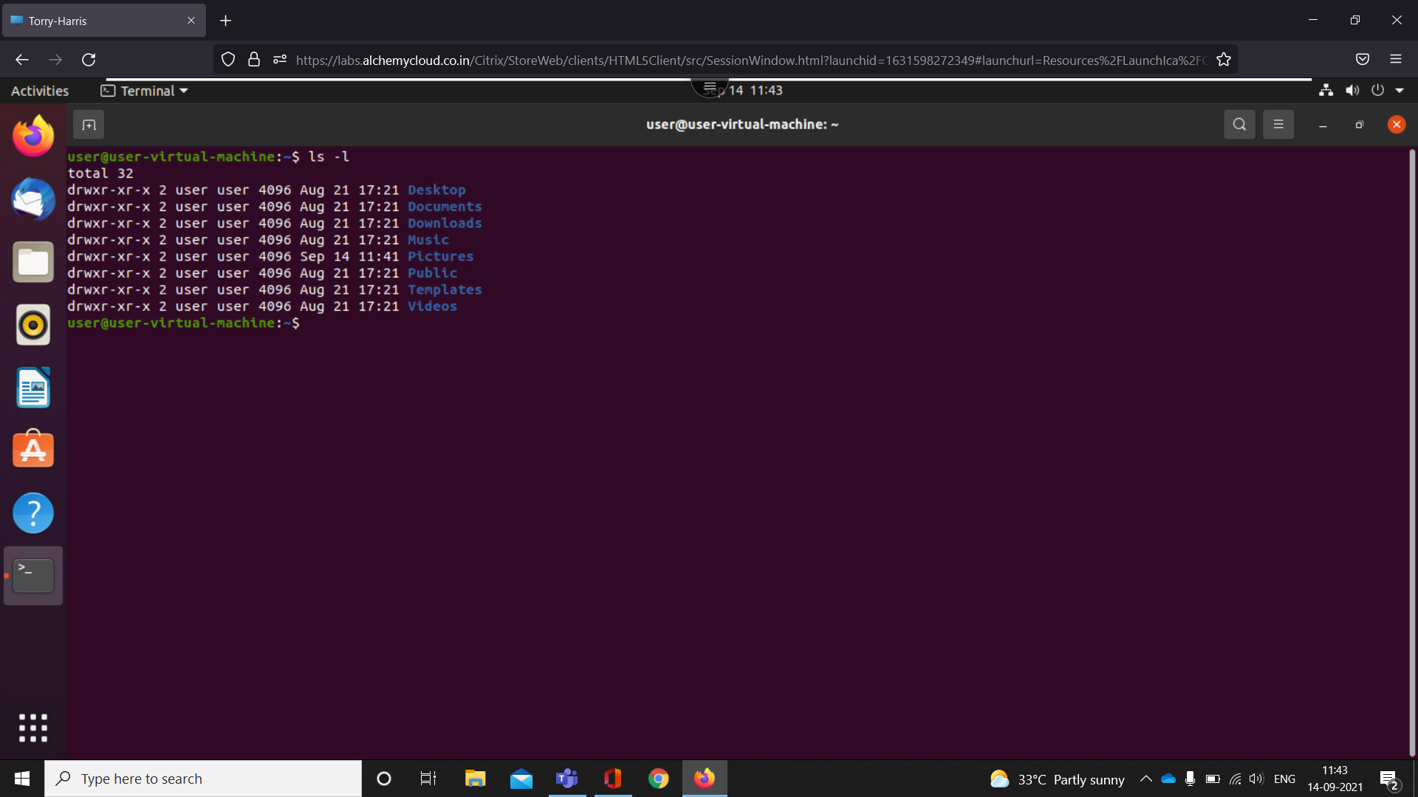

It is used to list information about files and directories within the file system.

1. ls -lr

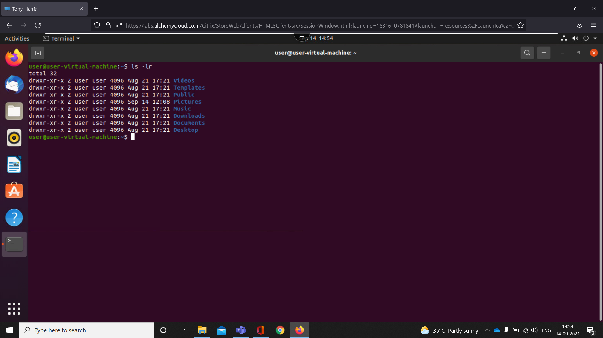

It is used to list information about files and directories within the file system in reverse order.

1. Ls-a

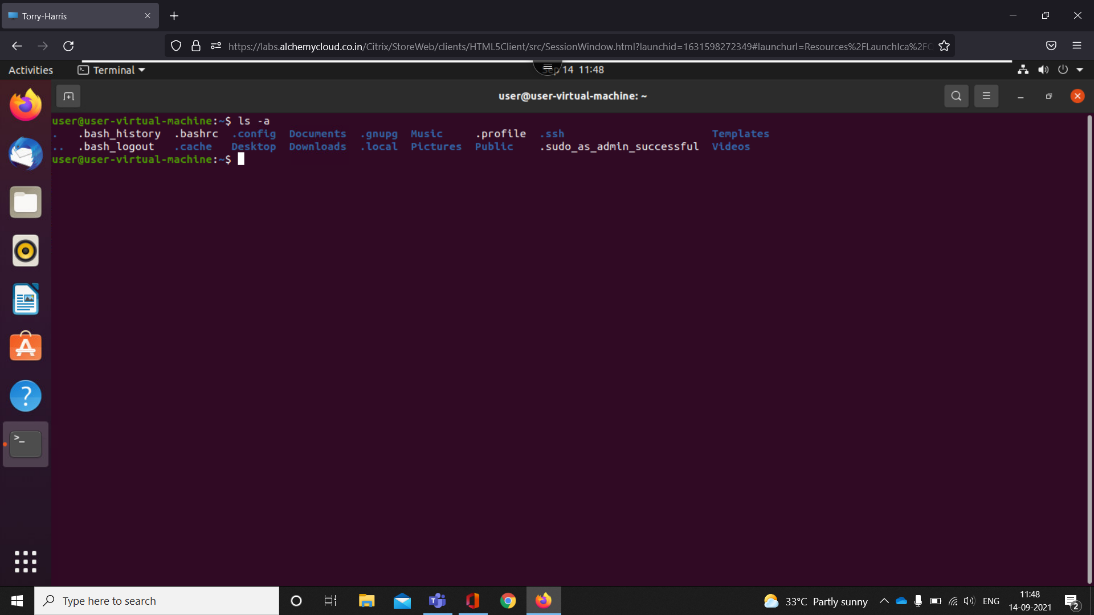

It is used to view a list of the hidden files and folders in a given directory

1. Ls-A

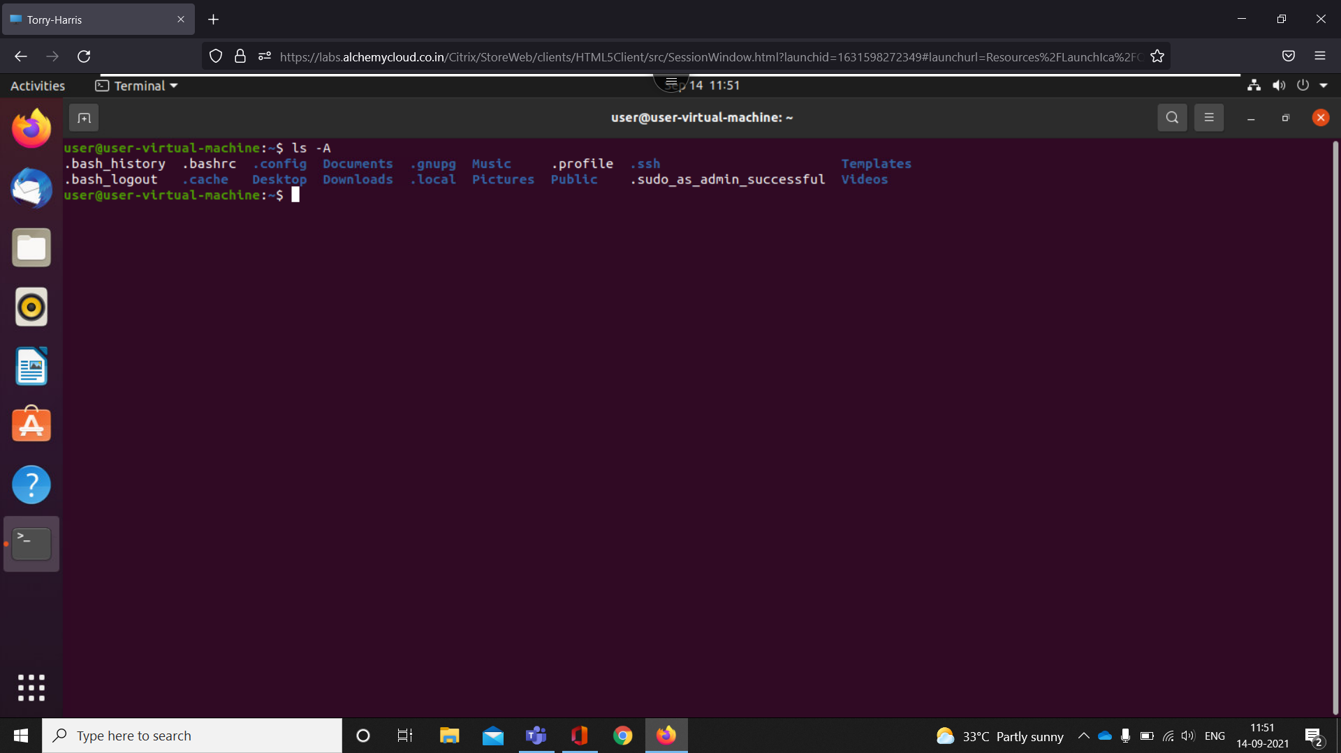

It is used to view a list of the hidden files and folders in a given directory ignoring that 2 hidden files

1. Cd

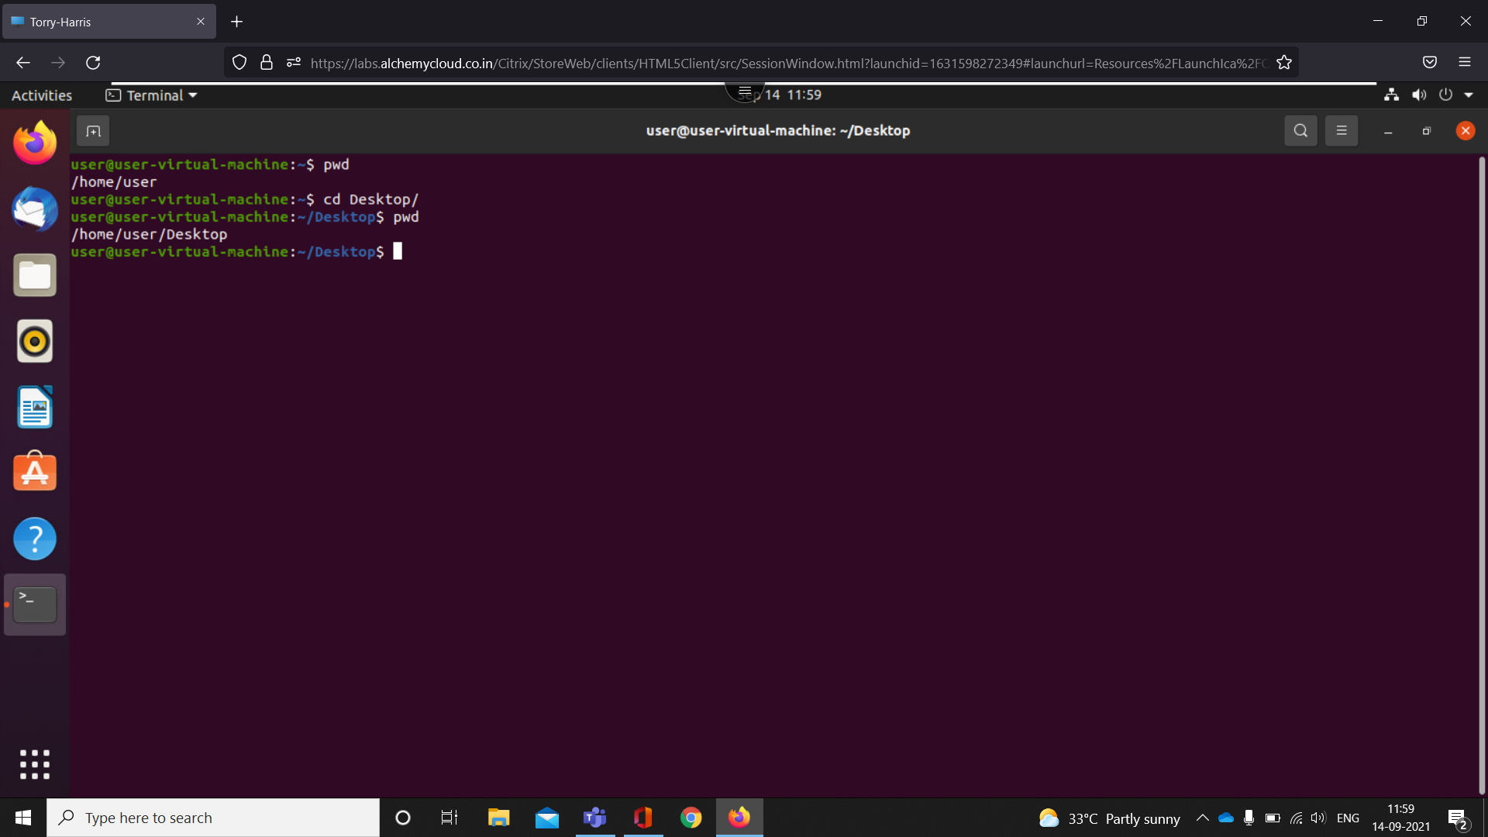

Linux cd command is used to change the current working directory

1. Cd ..

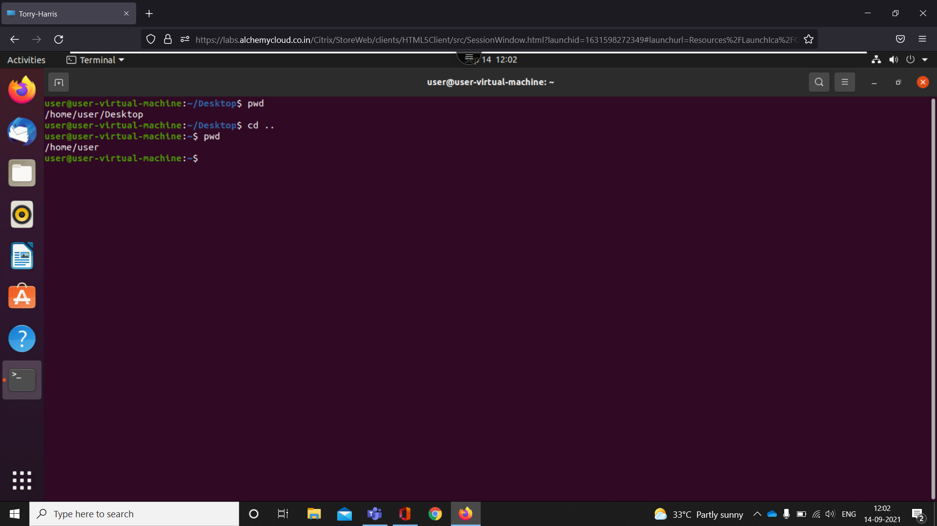

Cd .. command is used to move back to previous directory

1. Cd /

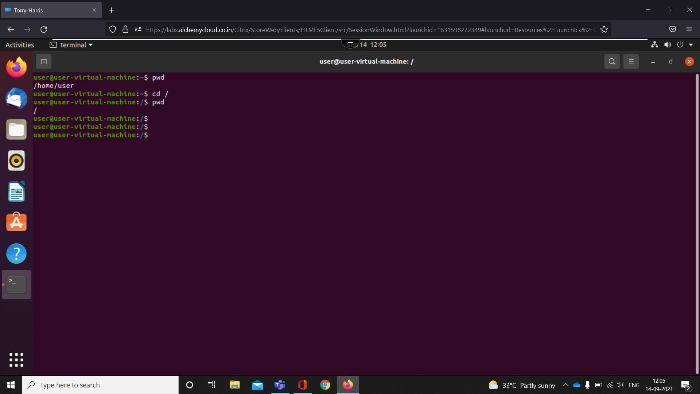

Cd / command is used to enter to root directory

1. Cd ~

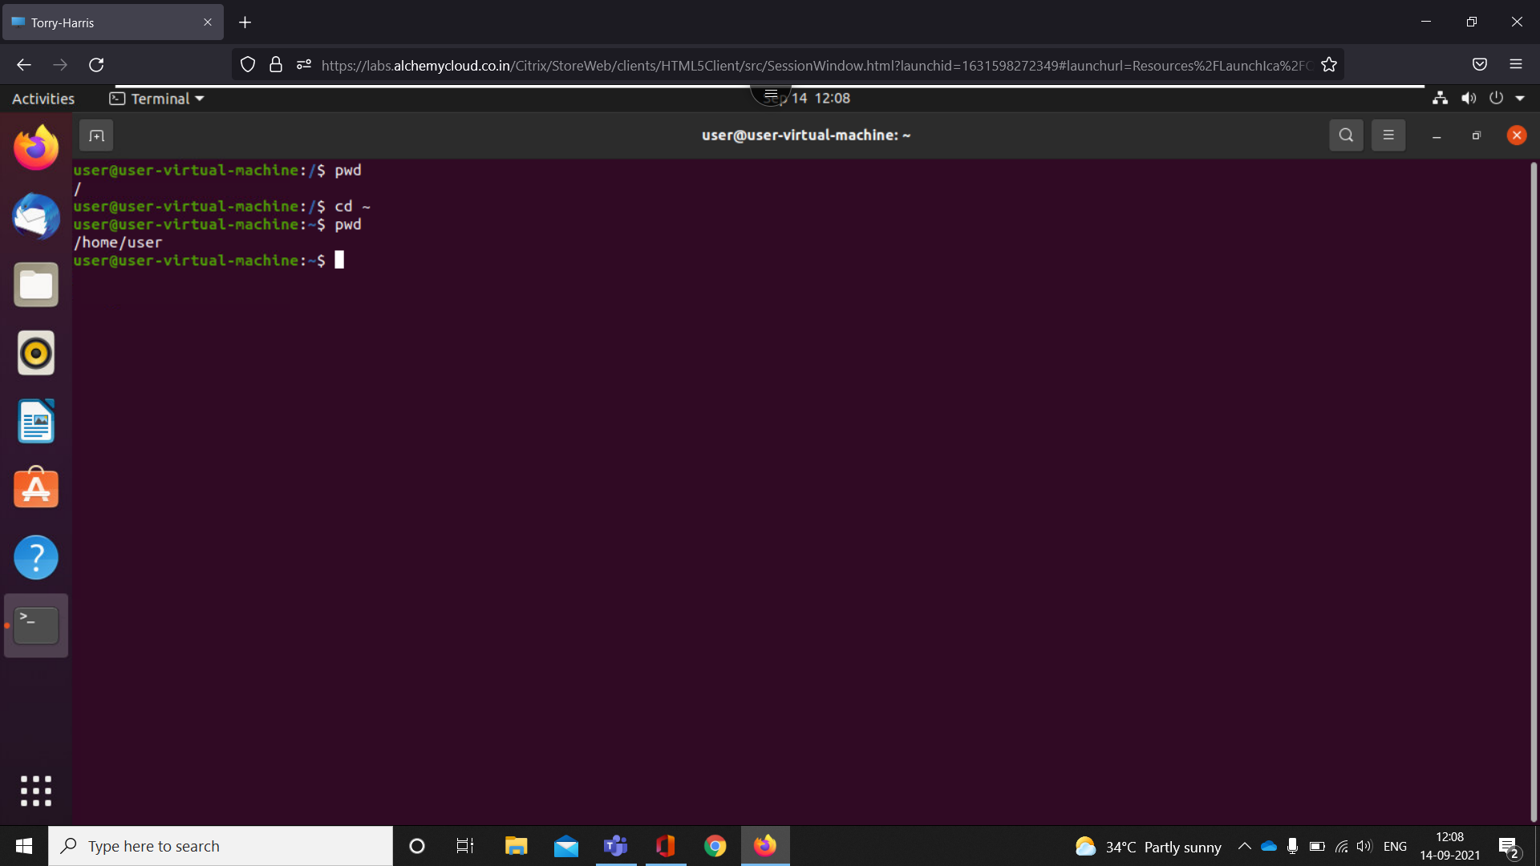

Cd / command is used to enter to user directory

1. Ls – f

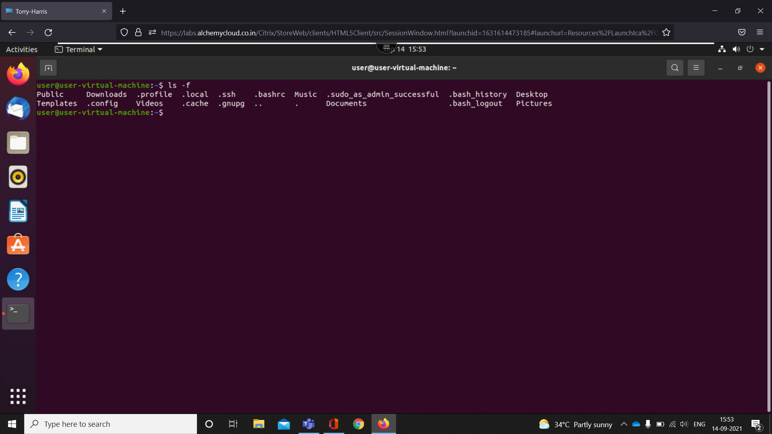

Ls –f command is used to list all the files without any format

1. Exit

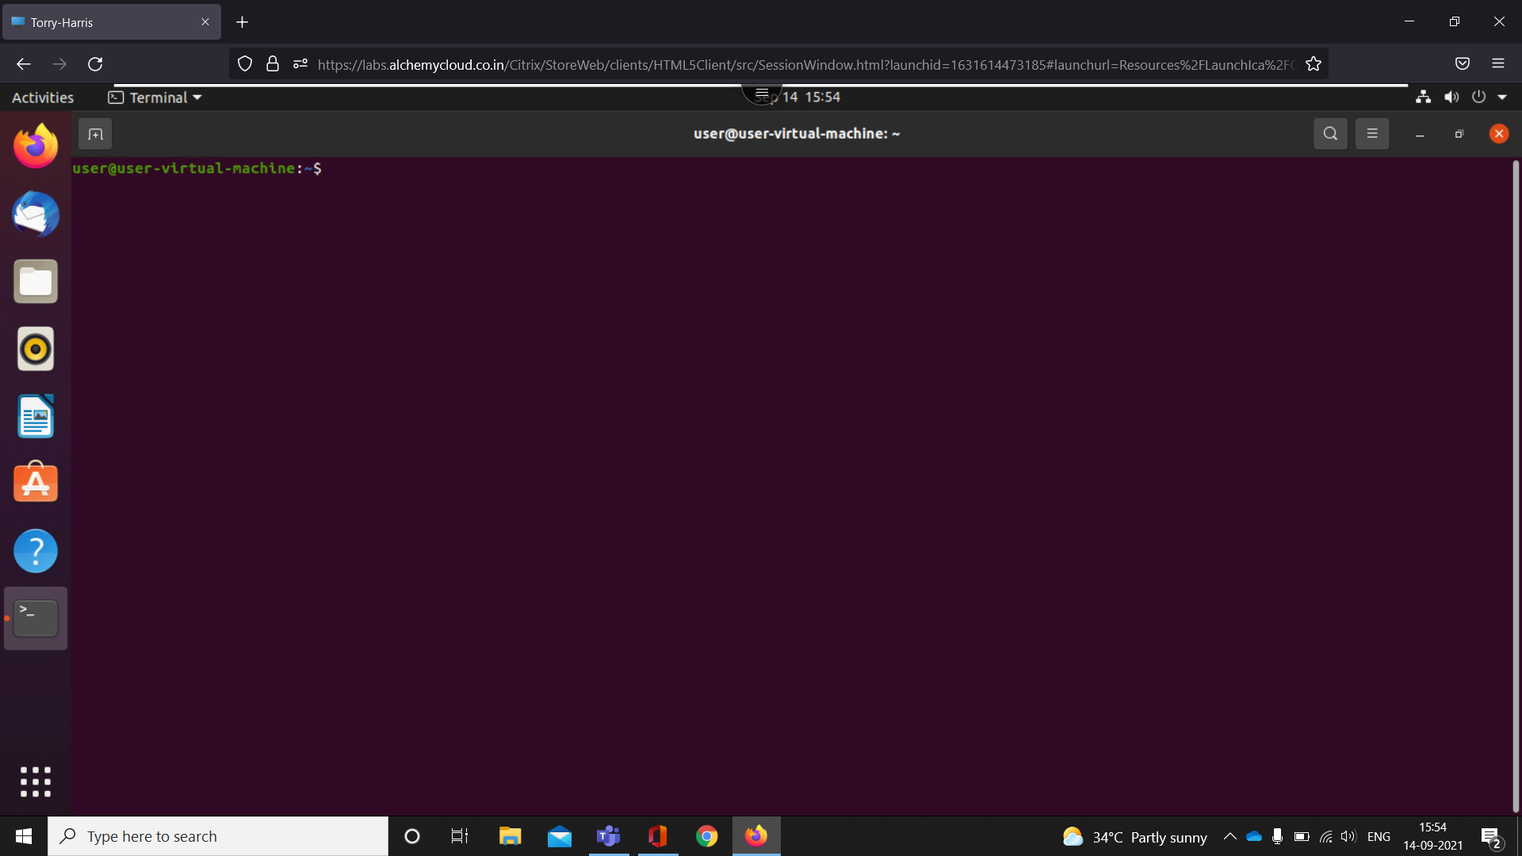

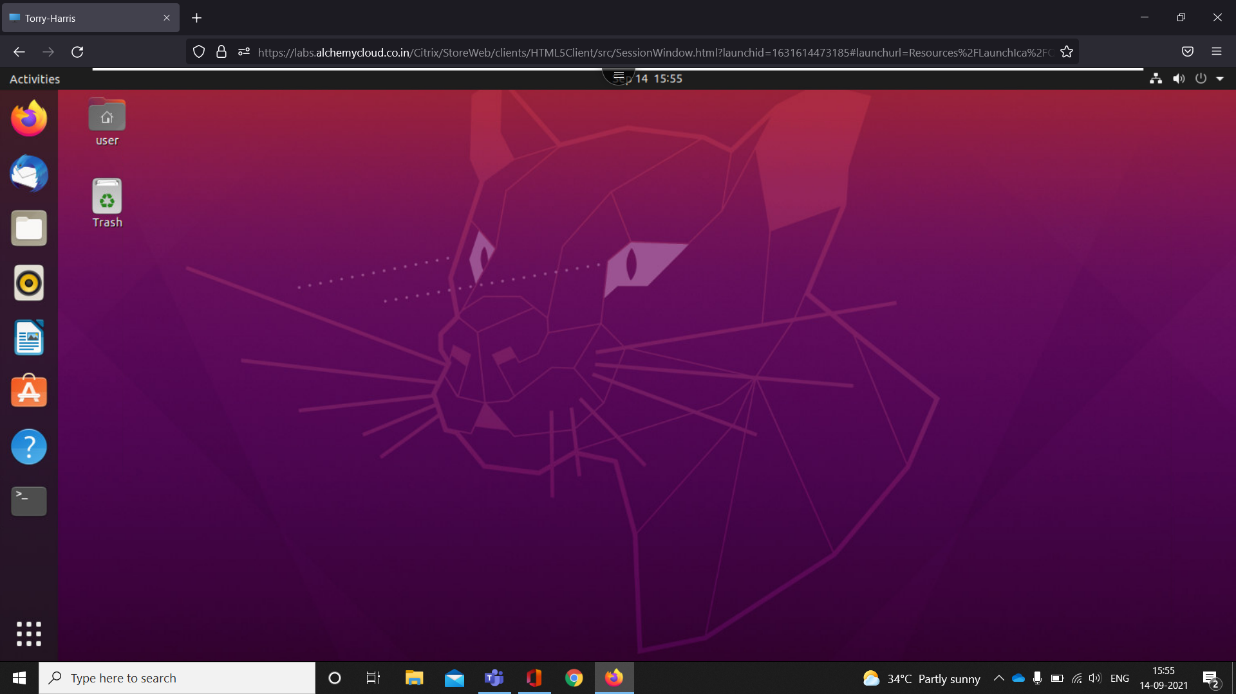

exit command in Linux is used to exit the shell where it is currently running

1. Cat

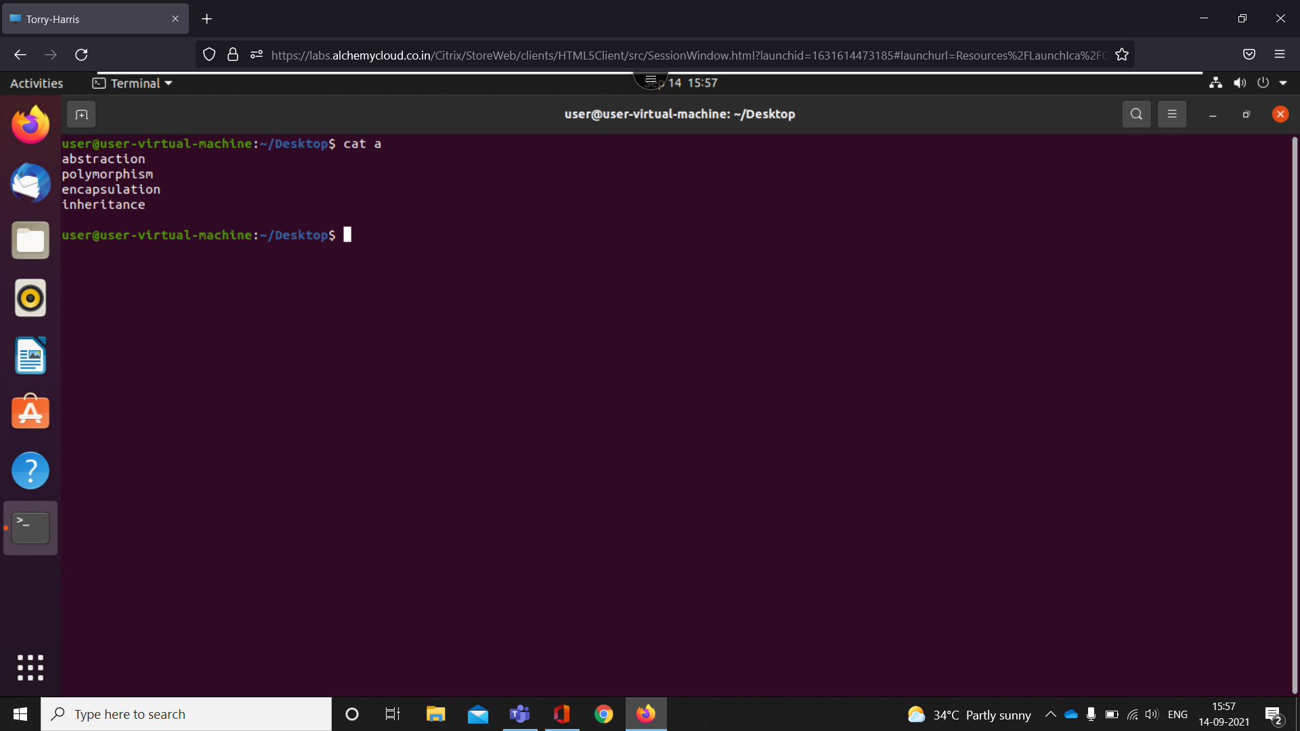

It reads data from the file and gives their content as output.

1. tac

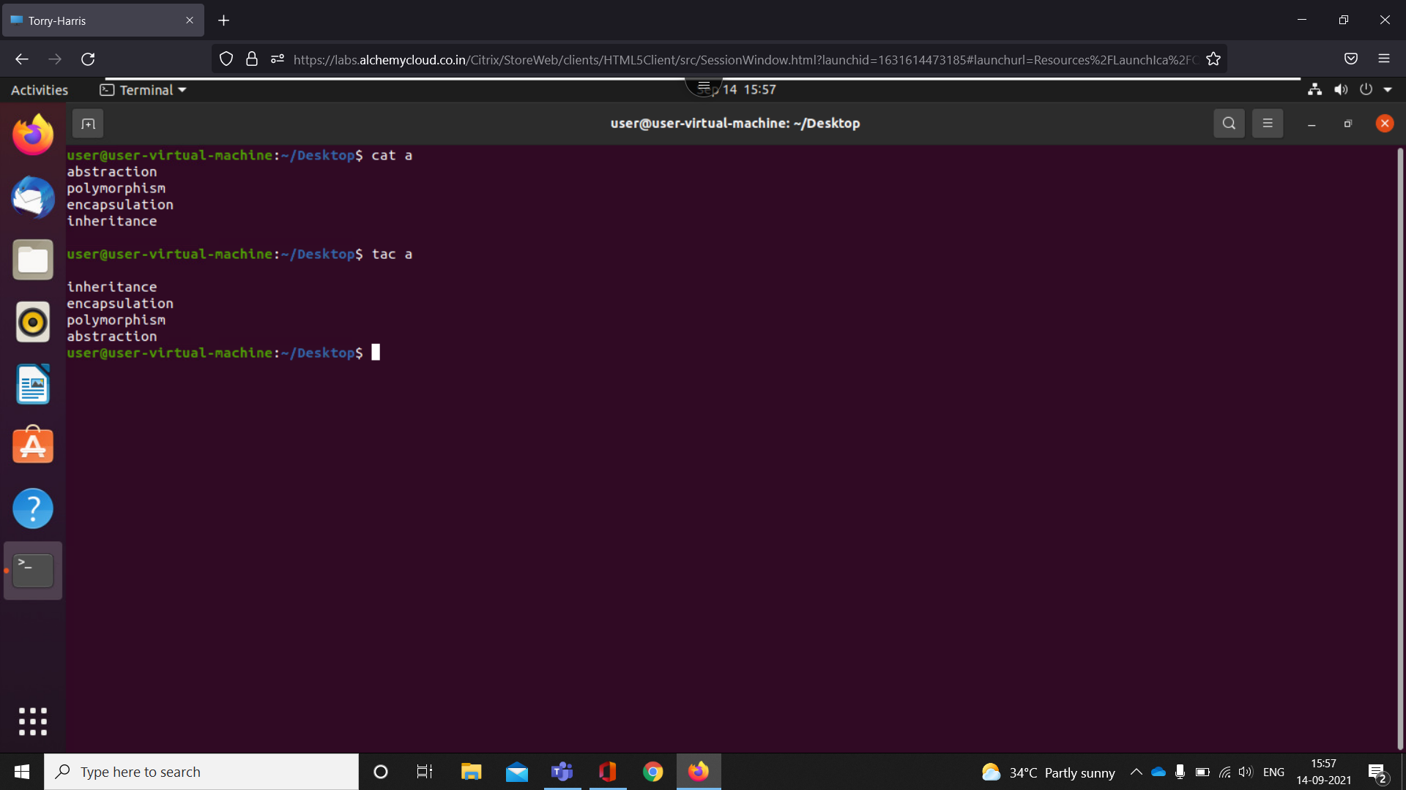

tac command in Linux is used to concatenate and print files in reverse

1. cat -b

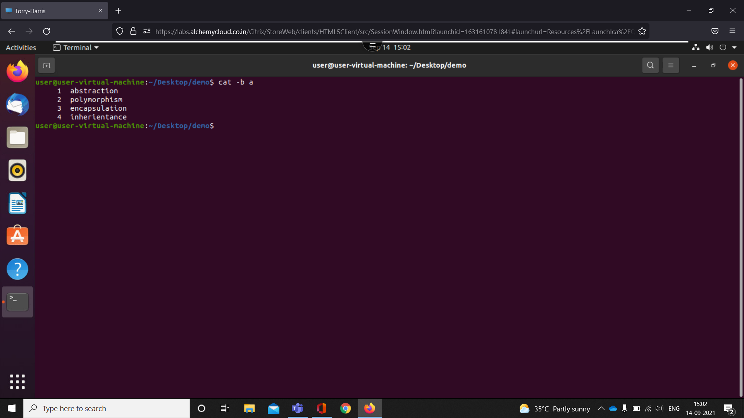

It reads data from the file and gives their content as output with line no.

1. sort

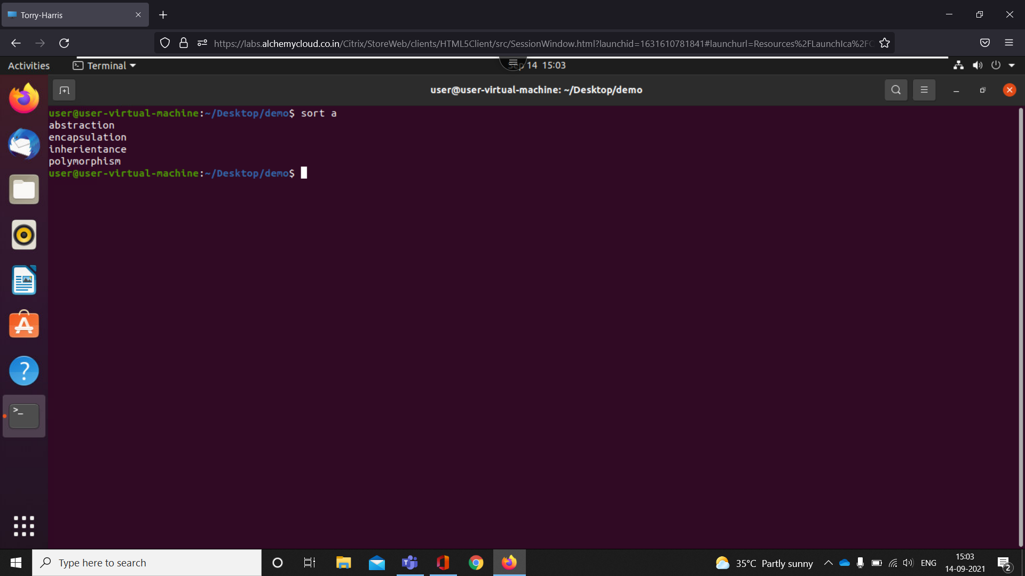

SORT command is used to sort a file, arranging the records in a particular order

1. man

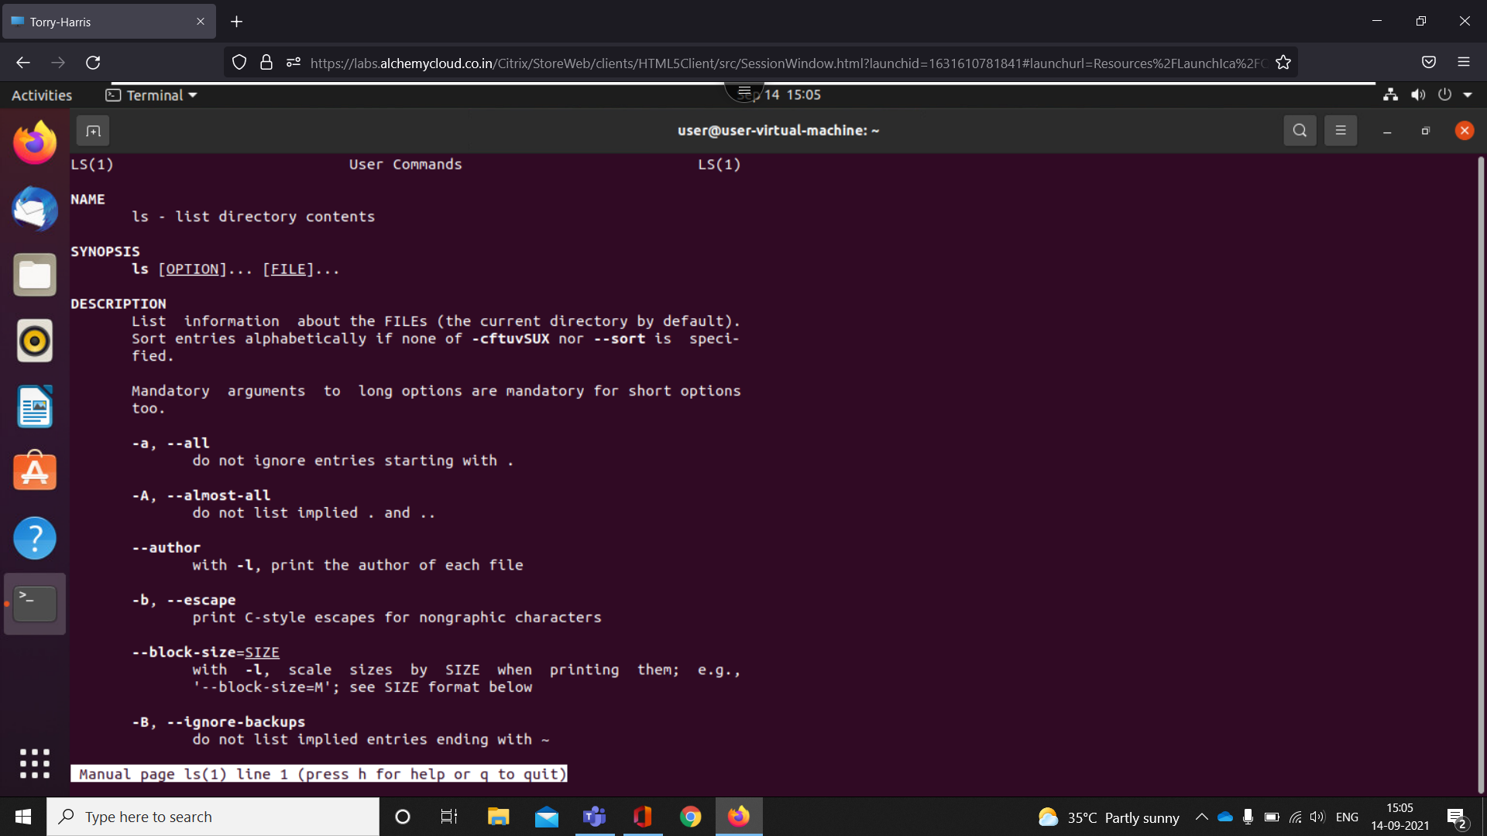

man command in Linux is used to display the user manual of any command that we can run on the terminal.

1. Echo

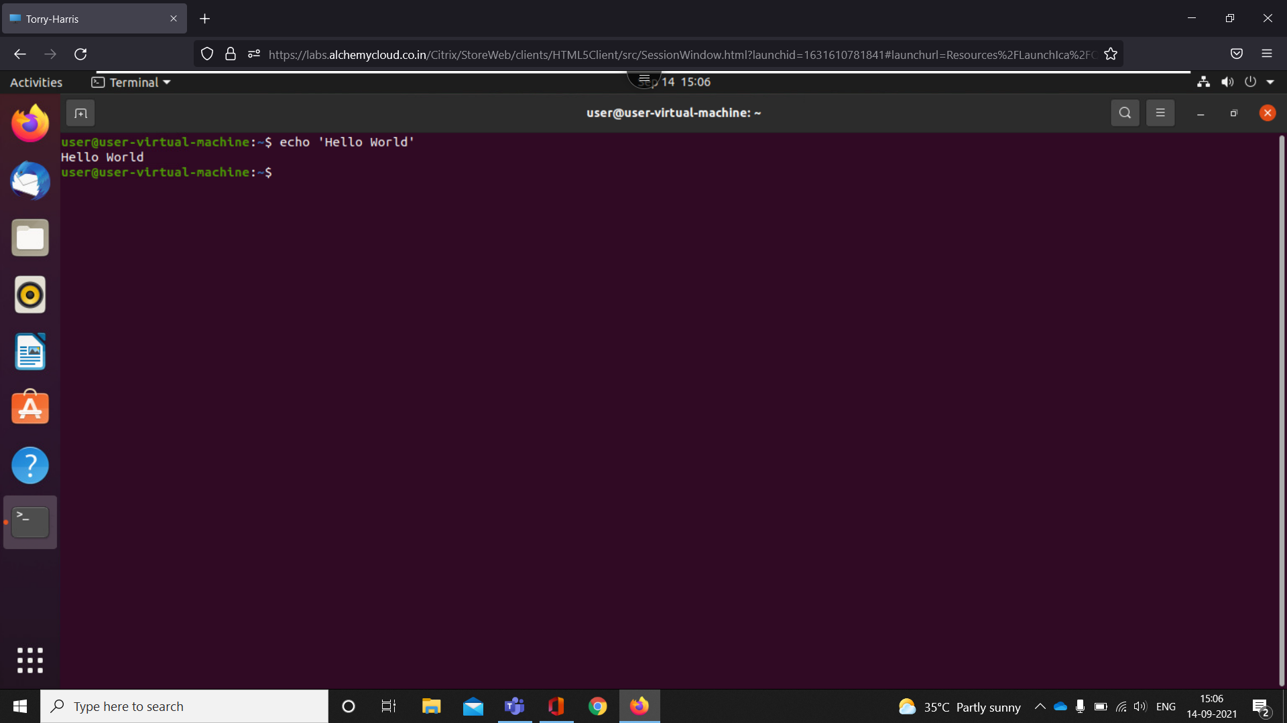

echo command in linux is used to display line of text/string that are passed as an argument

1. Mkdir

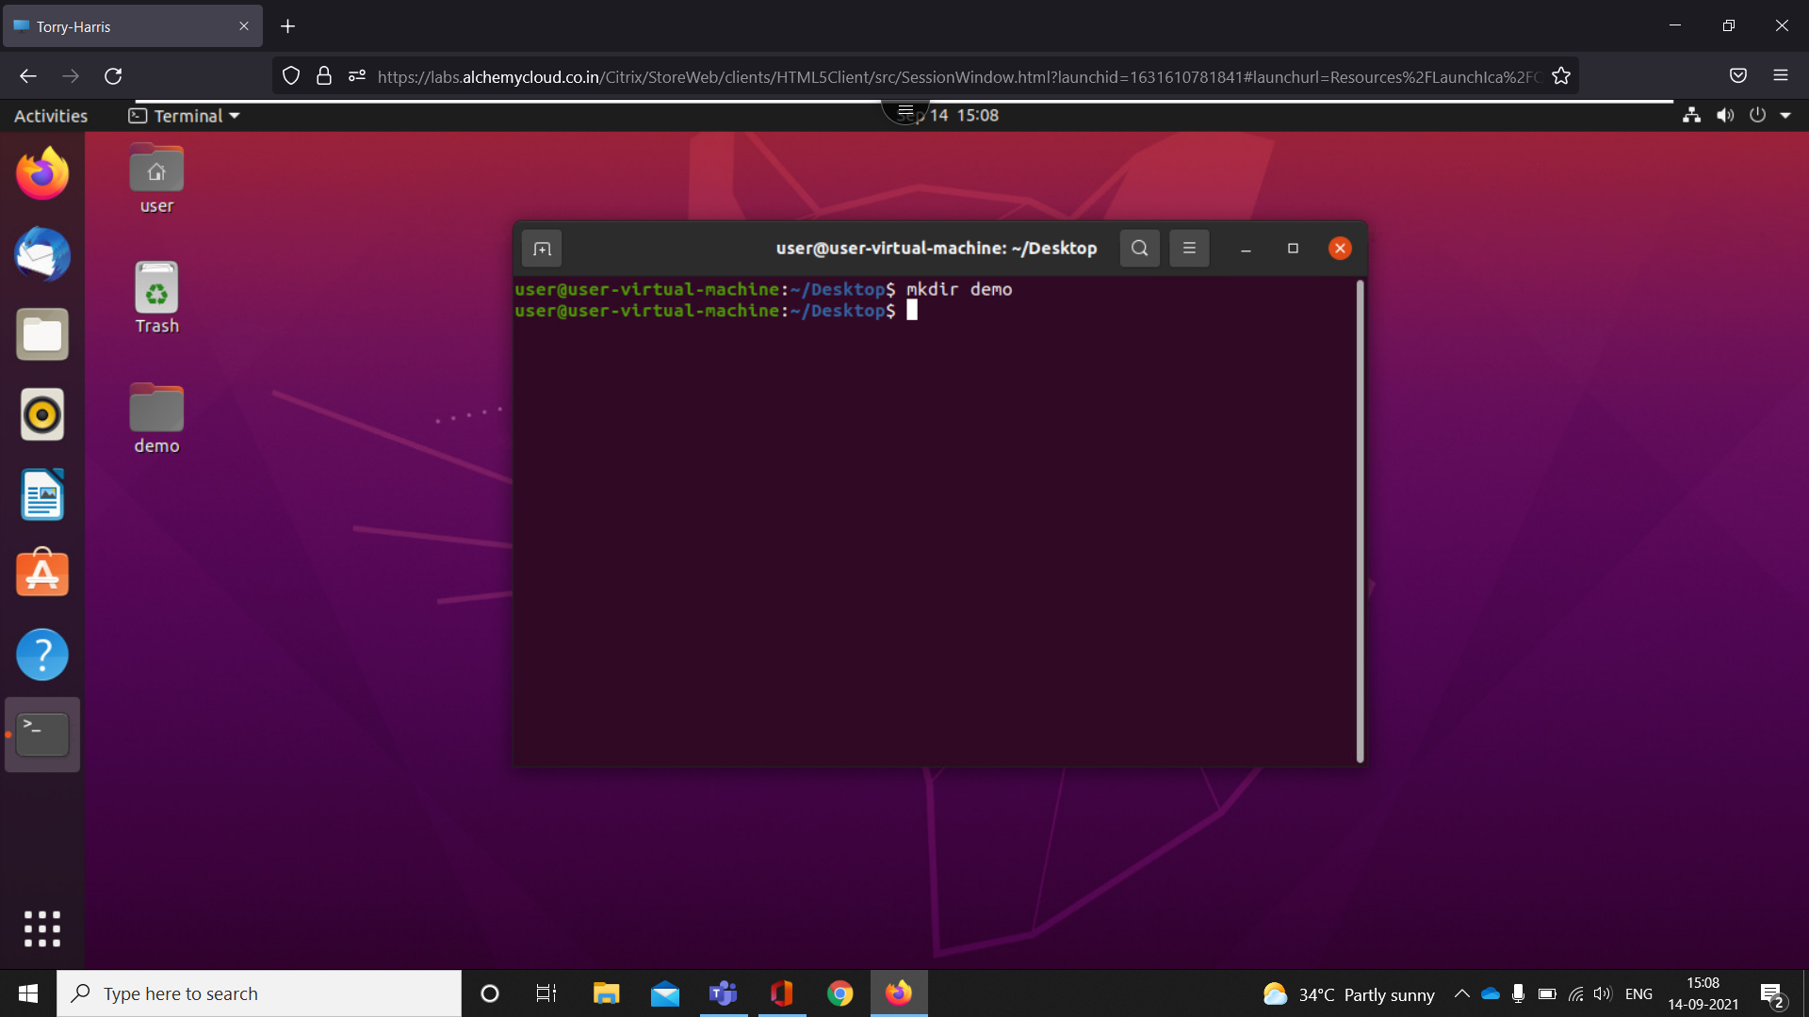

mkdir command in Linux allows the user to create directories

1. Mkdir file{1,2,3}

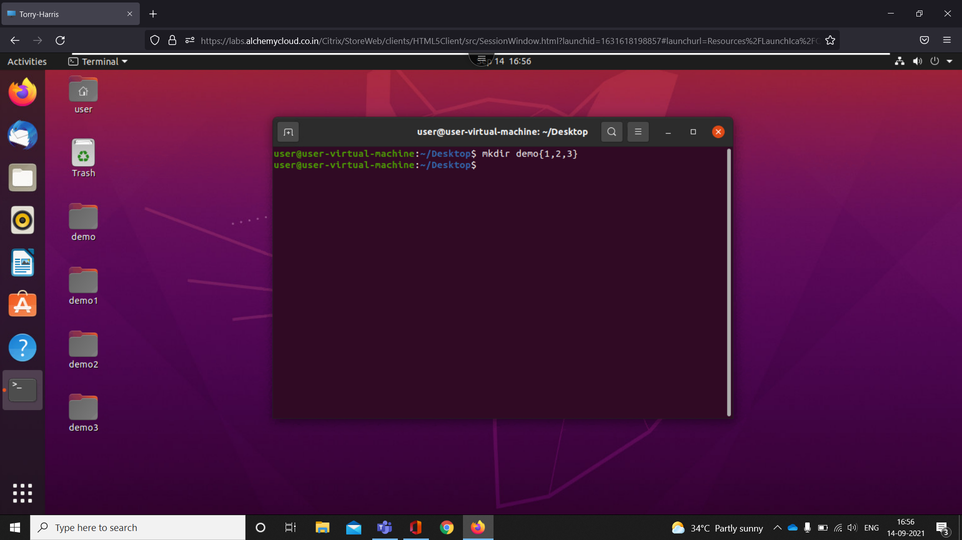

It create multiple files with successive file names

1. rmdir

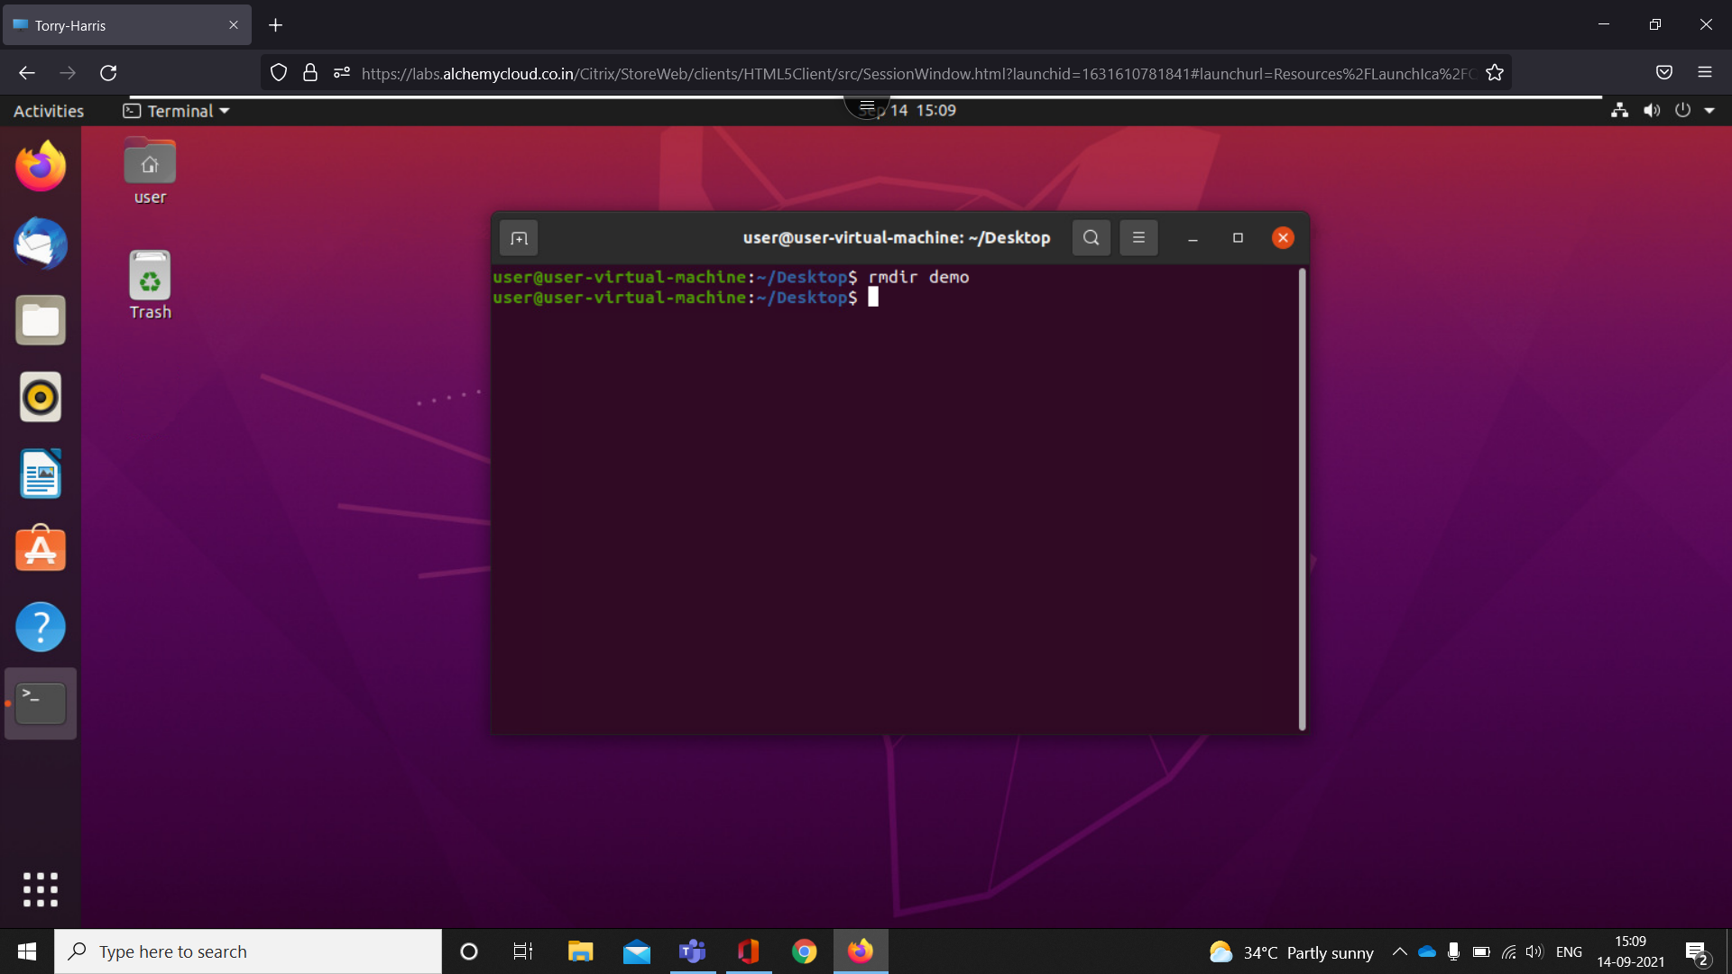

rmdir command is used remove empty directories from the filesystem in Linux

1. who

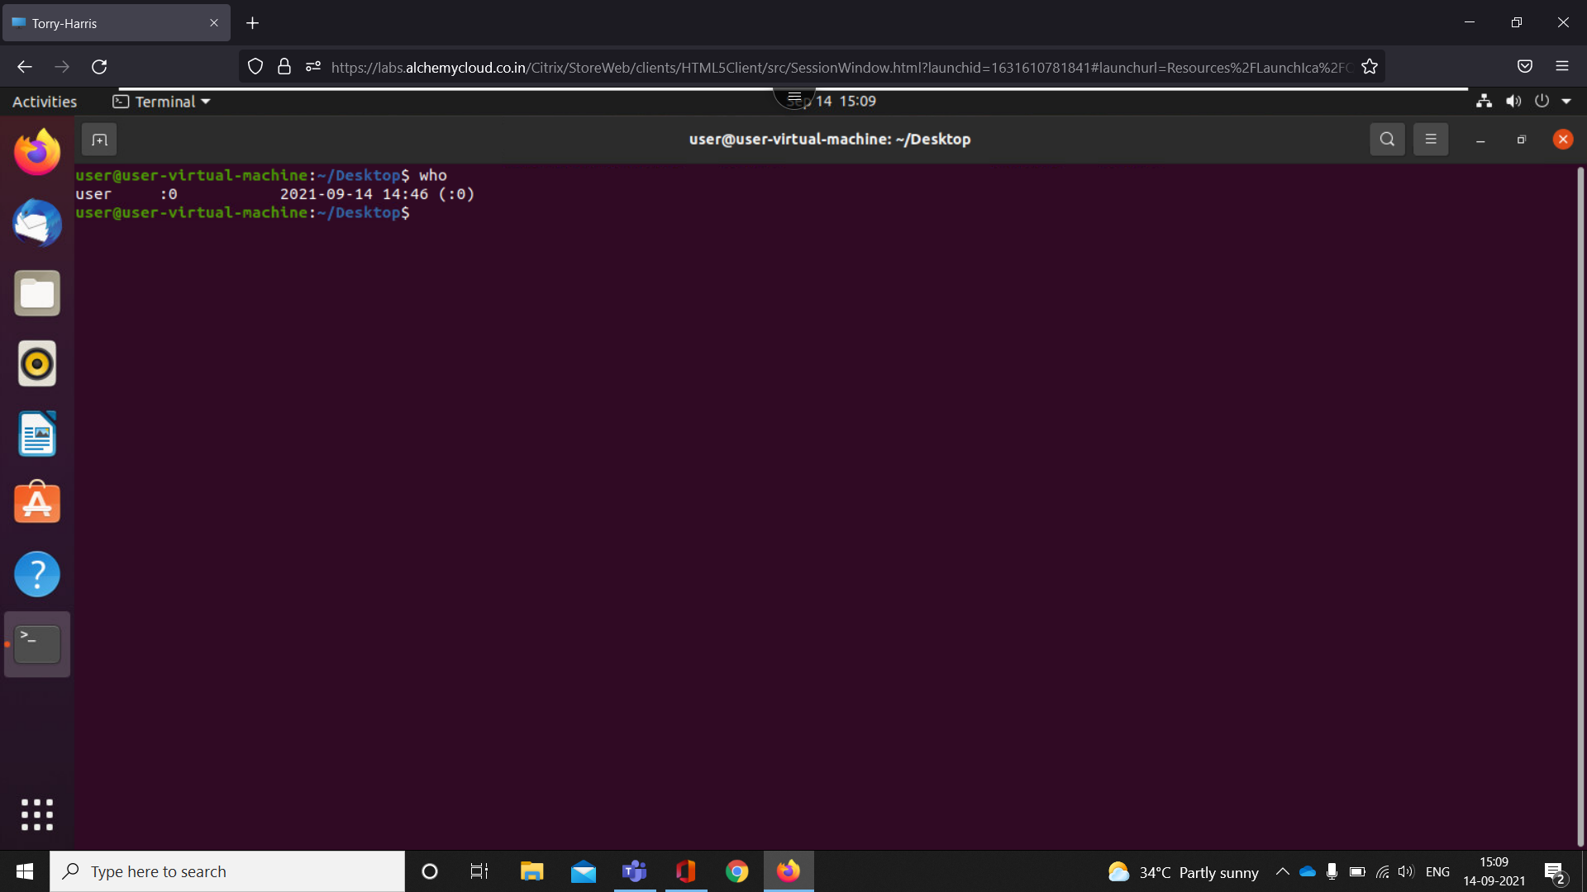

The Linux "who" command lets you display the users currently logged in to your UNIX or Linux operating system

1. date

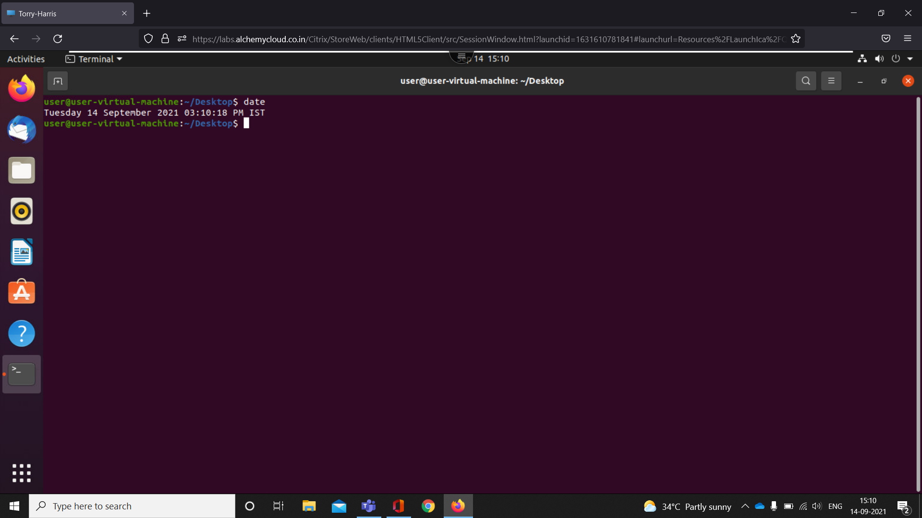

date command is used to display the system date and time.

1. cal

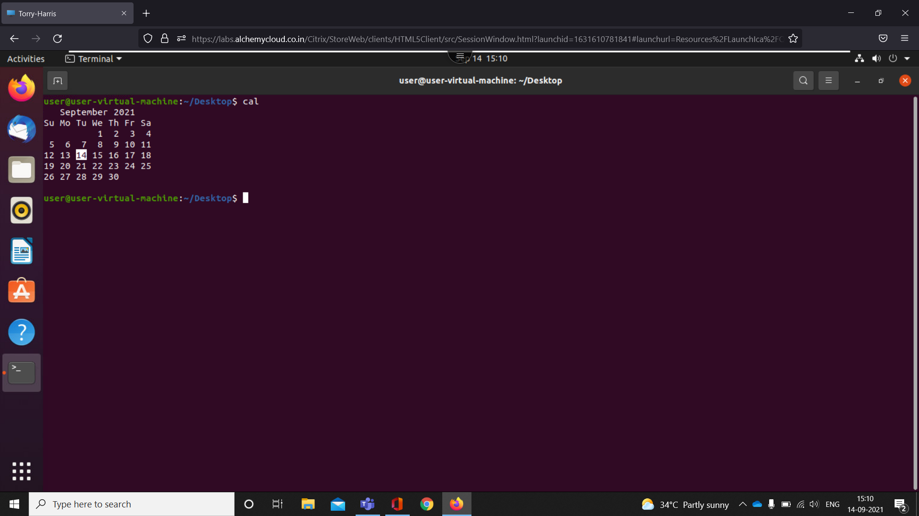

cal command is a calendar command in Linux which is used to see the calendar of a specific month or a whole year.

1. touch

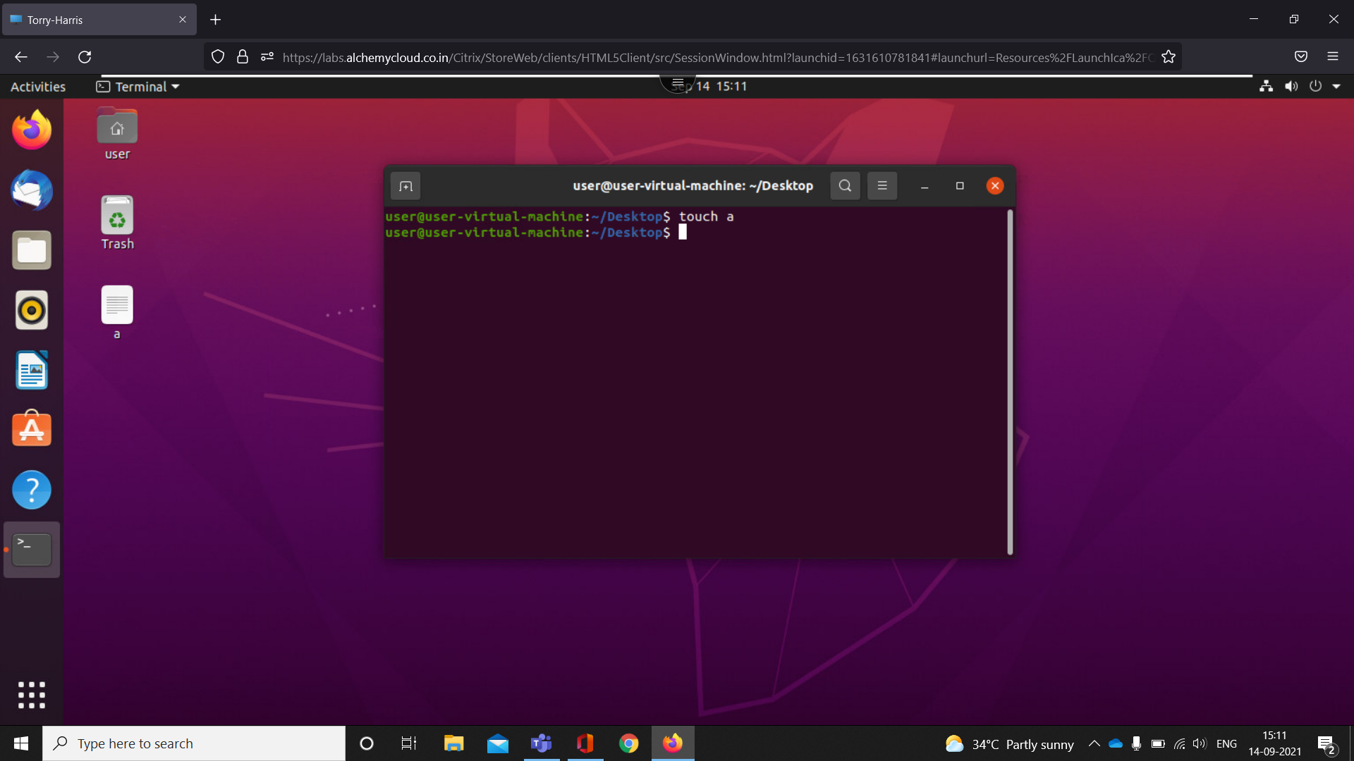

The touch command is a standard command used in UNIX/Linux operating system which is used to create, change and modify timestamps of a file.

1. rm

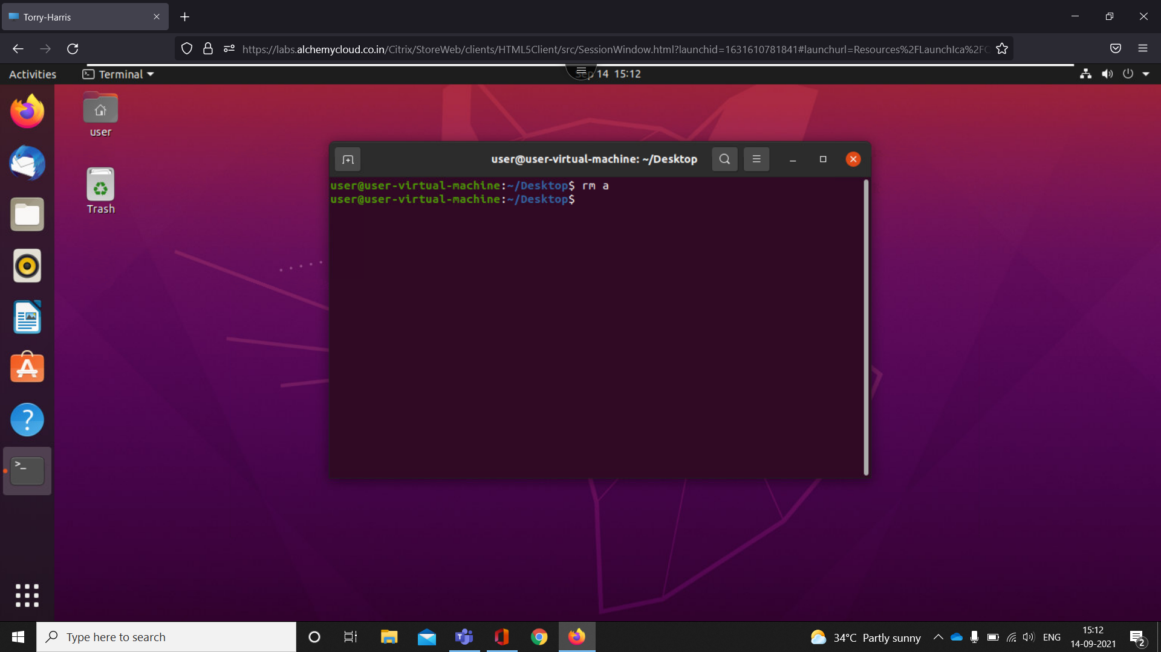

The rm command is used to delete files.

1. cp

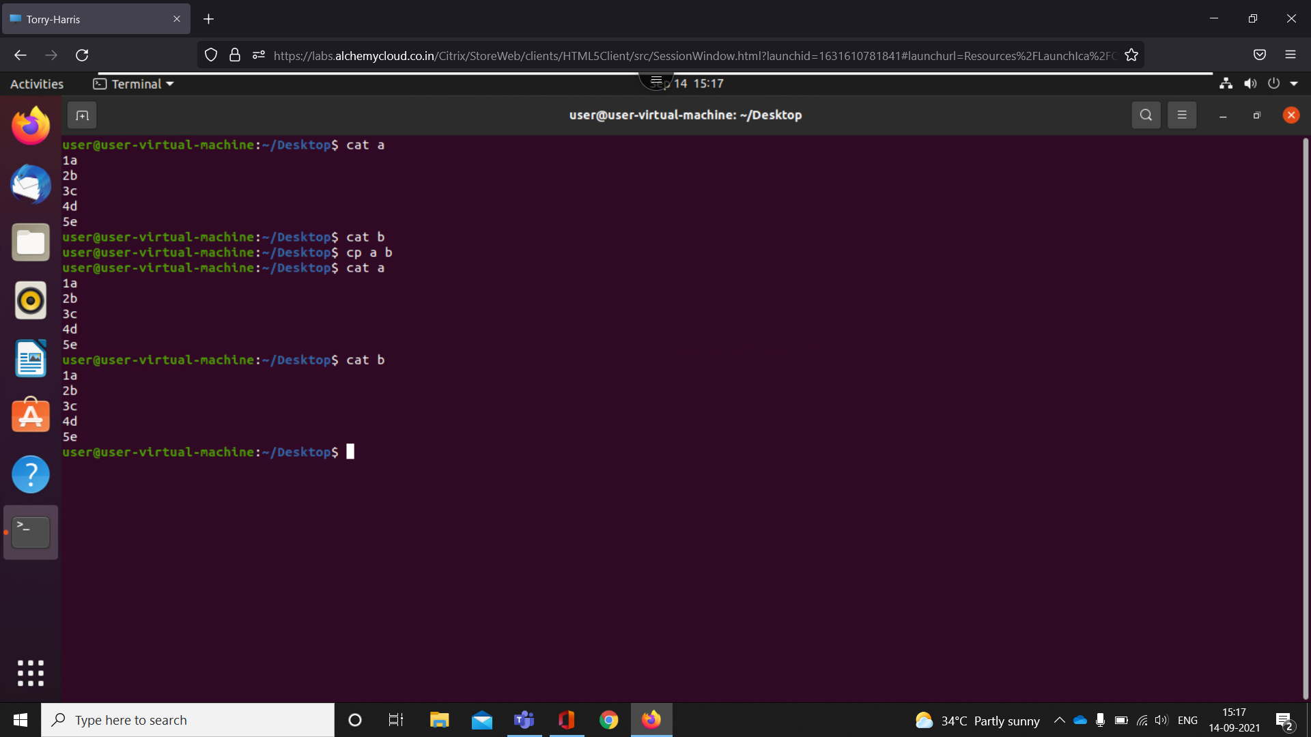

This command is used to copy files or group of files or directory

1. mkdir -p

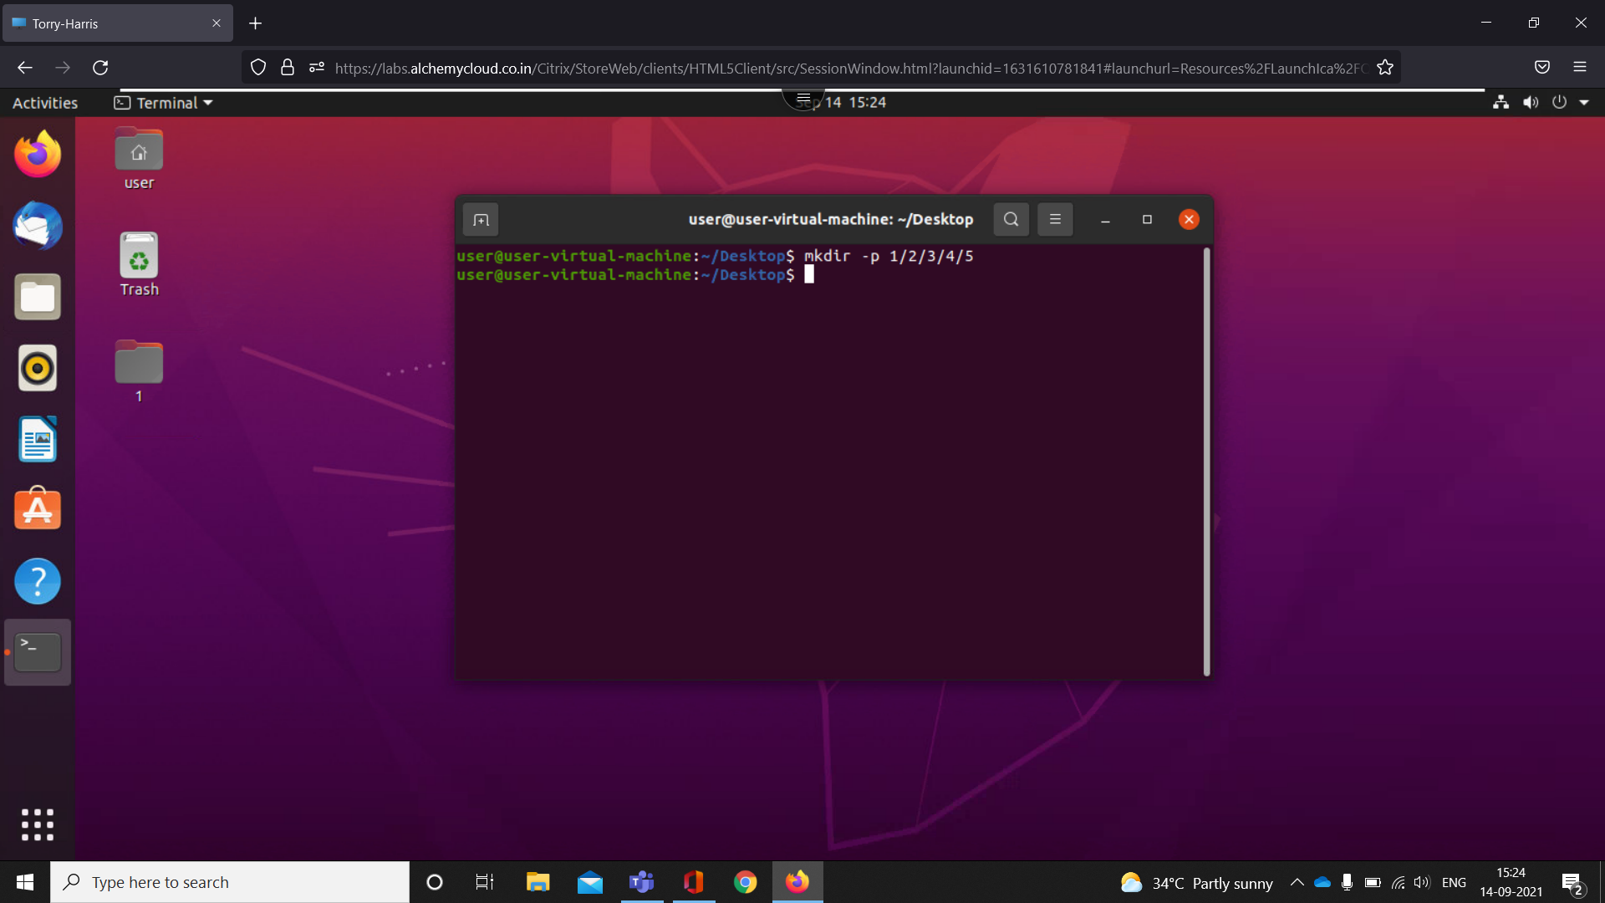

This command is used make directory one inside another

1. rm -rf

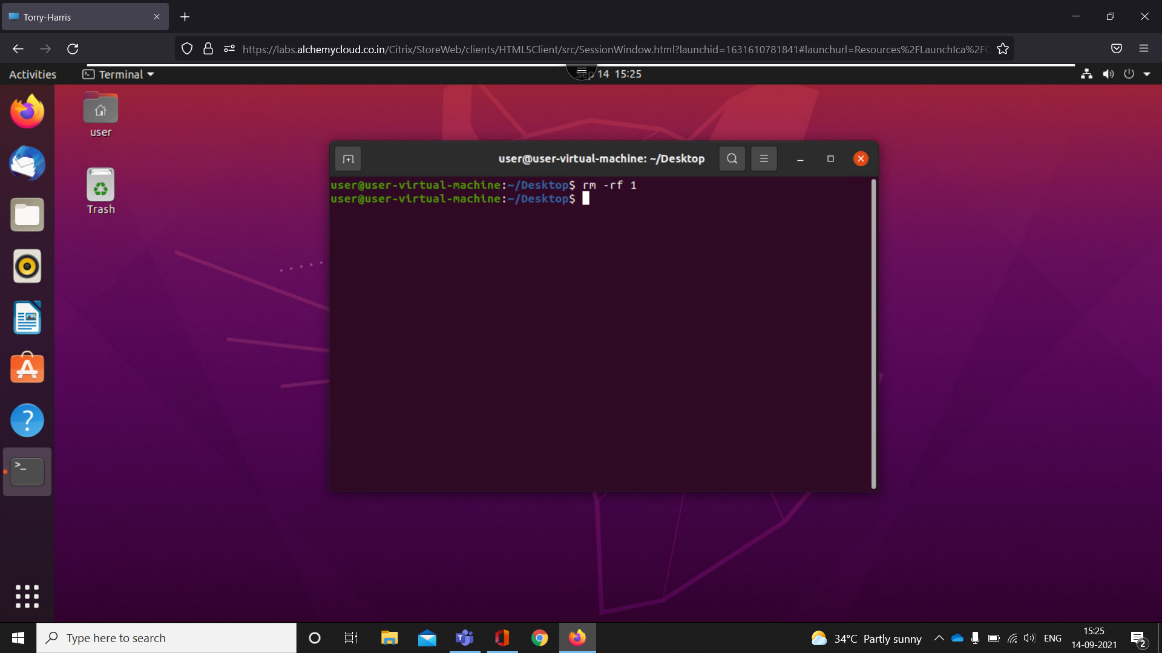

This command is used to delete all the files in directory

1. passwd

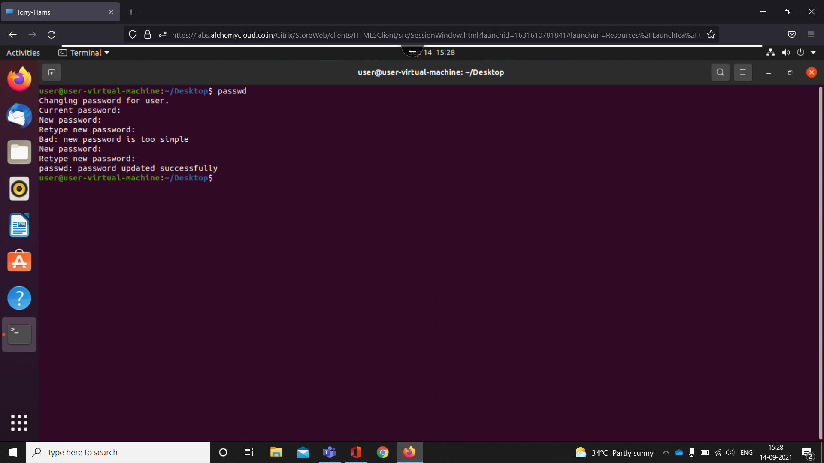

The passwd command changes passwords for user accounts

1. Sudo apt install tree

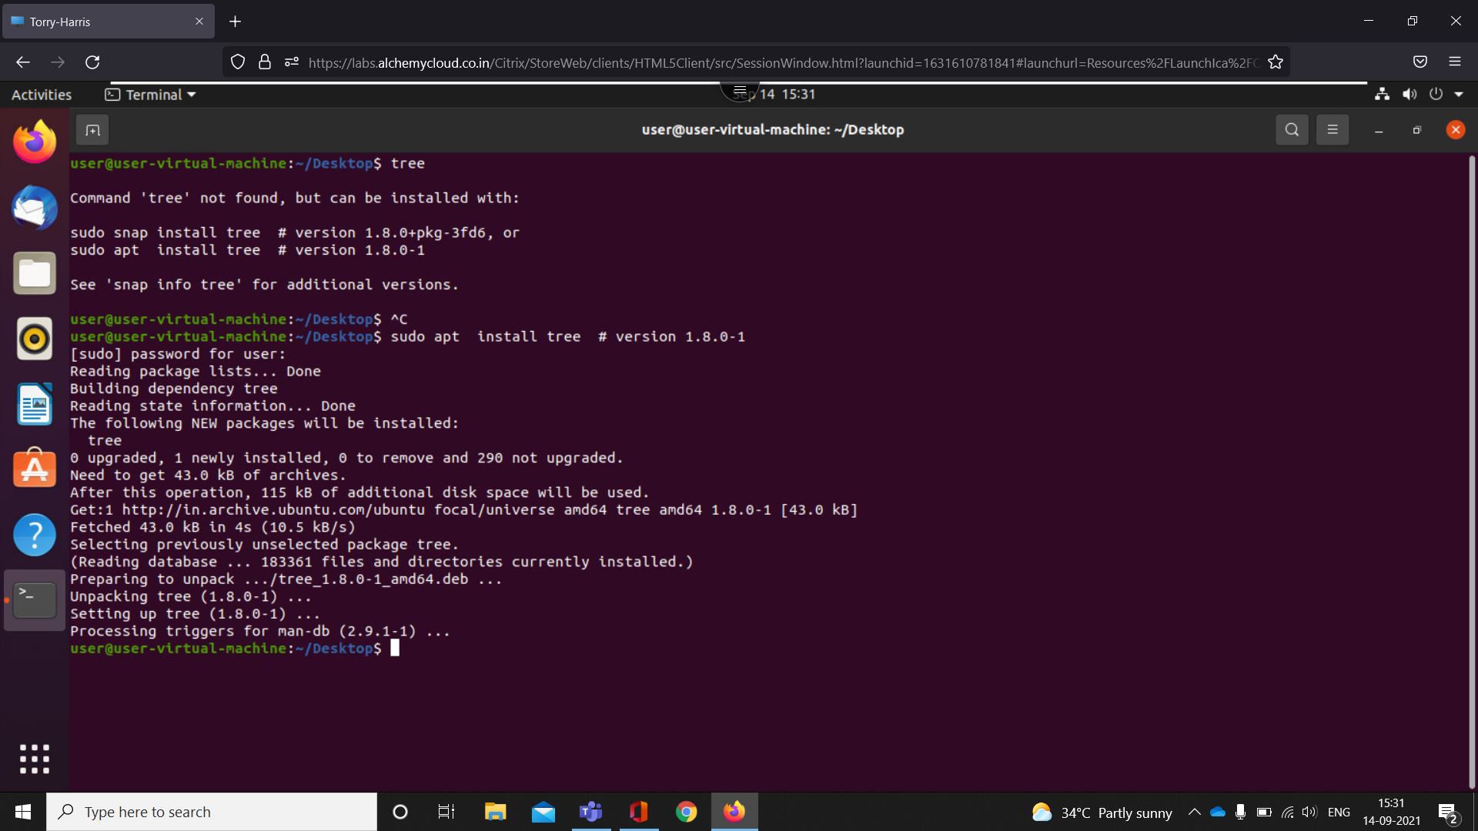

-install the apt

1. tree

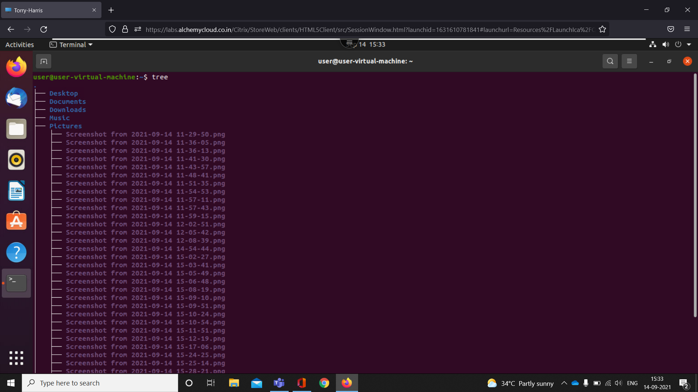

tree is a recursive directory listing program that produces a depth-indented listing of files

1. tree -d

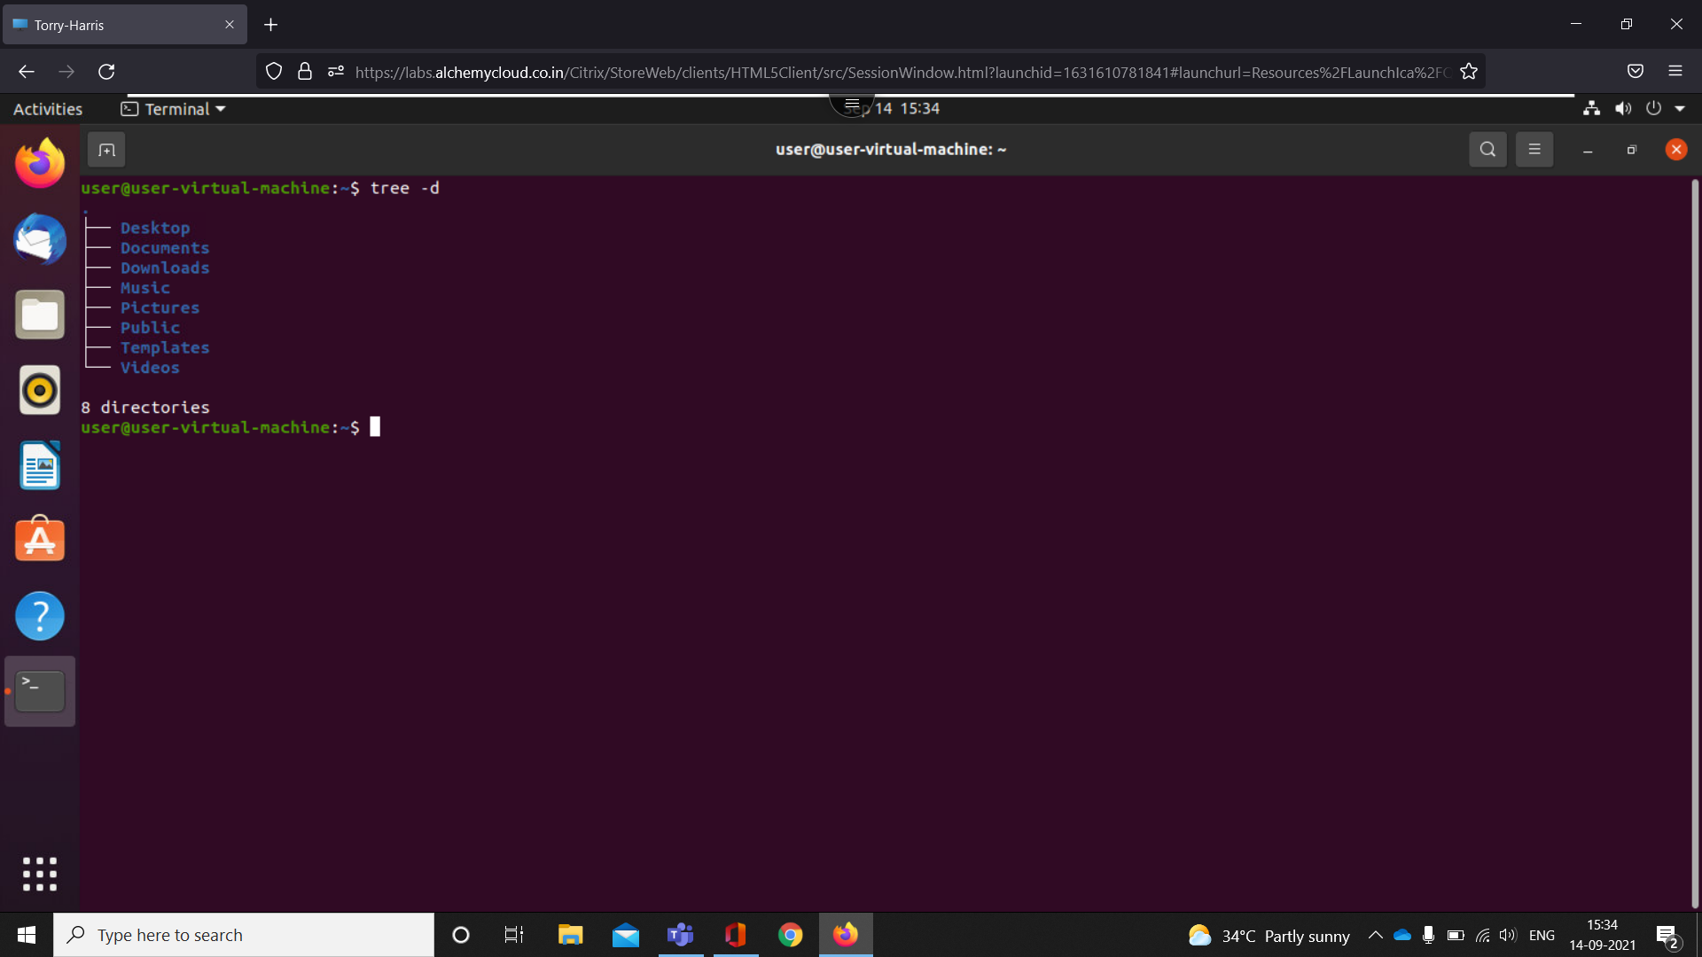

-only shows directory

1. --help

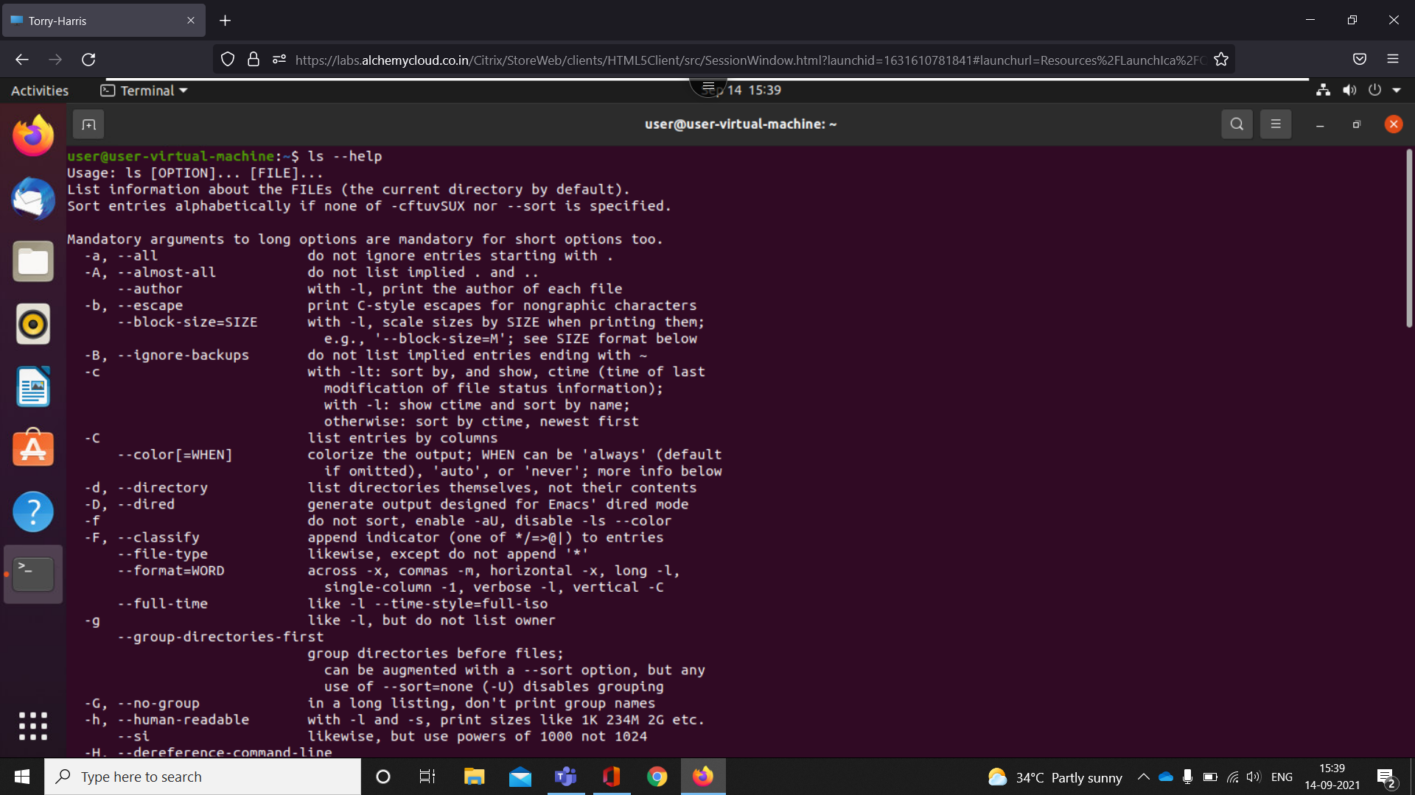

-for help

1. Mv

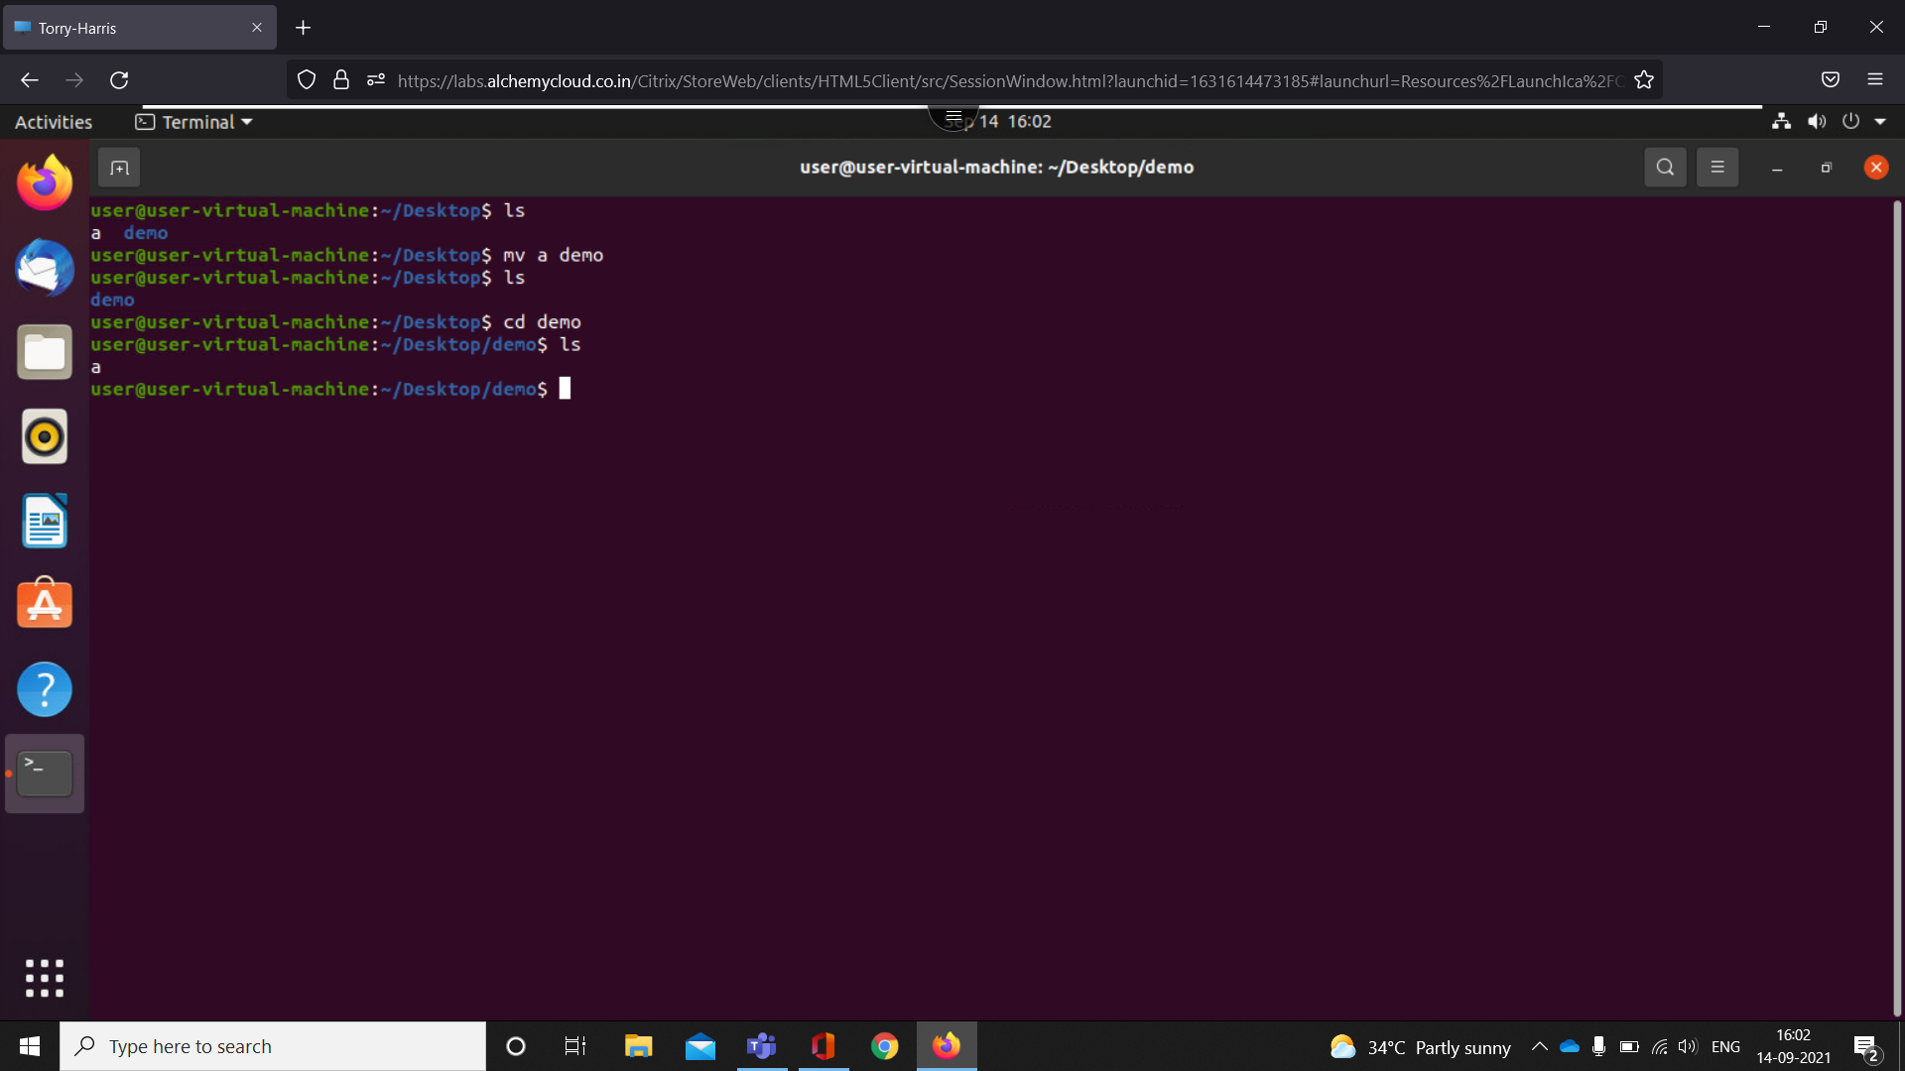

-move command

1. sudo apt-get update -downloading the updated version
2. sudo apt-get upgrade -install the downloaded version
3. sudo apt-get update && upgrade -download and install the update version